Suggestions for Conducting Group Activities (Reference)
The following group activity formats and exercises are offered as examples of ways to engage the NAC to find common ground, identify and prioritize concerns among the group, and bring forth assumptions. You would likely not use all of these exercises at once, but you may find different exercises useful when conducting a complete CNA with a newly formed NAC versus conducting an update with returning members from a previous NAC.

Affinity Process
An Affinity Process may help a team with diverse members to discover the values that they hold in common and build consensus to facilitate planning and decision-making. The facilitator should provide a series of prompts written on a piece of chart paper. Questions may include the following:
What is the purpose of the MEP?
What are the most important things we want for our migratory children and youth?
What is the goal of the CNA?
Step 1. Provide each team member with a pad of Post-It Notes and ask all team members to respond to the prompts, with each idea expressed in a complete sentence on separate Post-It Notes. They should work independently on this task.
Step 2. Organize team members into small groups, either by role group or in mixed groups.
Provide each group with several sheets of chart paper.
Provide the following instructions for the small group activity:
- One person will introduce an idea that he/she wrote and stick it on a piece of chart paper.
- Others will post similar or related ideas on the chart paper.
- The next person at the table will introduce an idea and follow the same process.
- The process will continue until all ideas are placed on the sheets of paper.
- The groups will be instructed to create three- to five-word headings for each of the sheets of paper.
Step 3. Reconvene the whole group.
Ask one group to place one of its chart sheets on the wall.
Invite other groups to place any sheets that are similar next to the first one.
Then invite the next group to place one of its chart sheets on the wall.
Invite other groups to post ones on similar topics.
Continue this process until all sheets are posted. This part of the process works best if the team members can walk around and read all the posted ideas.
Step 4. As the final step, reconvene the small groups to discuss which concepts they feel are most important and craft a rough statement that uses the short headings from the chart sheets to convey their perspectives. These statements will be shared with the whole group and later provided to the team as guiding principles for crafting the Service Delivery Plan (SDP).
This process will take one to two hours.

Brainstorming
Brainstorming around the question of “Where are we now?” is a quick way to generate a list of concerns or problems that the team feels should be addressed. This technique can be done at various times during the planning process when the group seems “stuck” or the energy is low. The activity can be done easily in five to seven minutes.
The facilitator should explain that team members should state their ideas briefly without explanation, and no idea is to be judged as it is presented. The facilitator should provide a prompt, such as “The greatest challenges for migratory children in our state are …” When the activity begins, the facilitator, and perhaps another person to assist, should capture every idea on chart paper.
After the generation phase, one way to determine which ideas resonate with the group or to prioritize the ideas is to provide each team member with three to five colored sticky dots to place on the ideas that they feel are the most important. The ideas on the chart paper that have the most dots are the ones that should form the basis for further discussion.

Cause Effect Diagram (Fishbone)
This activity will help teams identify causes and contributing factors that must be considered in developing an effective plan. The facilitator should provide a problem statement or elicit one from the group. The problem statement should be written in a box on the right side of a sheet of chart paper positioned horizontally. A line should be drawn across the center of the paper with diagonal lines branching out. The diagram resembles a fish with bones branching out from the spine. On each of the branches, the group can identify causes they feel are related to the problem. (See Figure 2.C.1.) After many ideas are written on the diagram, the facilitator may want to have the team members identify the ones that they feel are most important. Providing each team member three to five colored sticky dots will enable them to note which causes they feel are the most significant and can lead to further discussion for how these will be addressed in the SDP. This activity can be conducted in 15 to 30 minutes, depending on the complexity of the diagram.

Figure 2.C.1. Sample Cause Effect Diagram
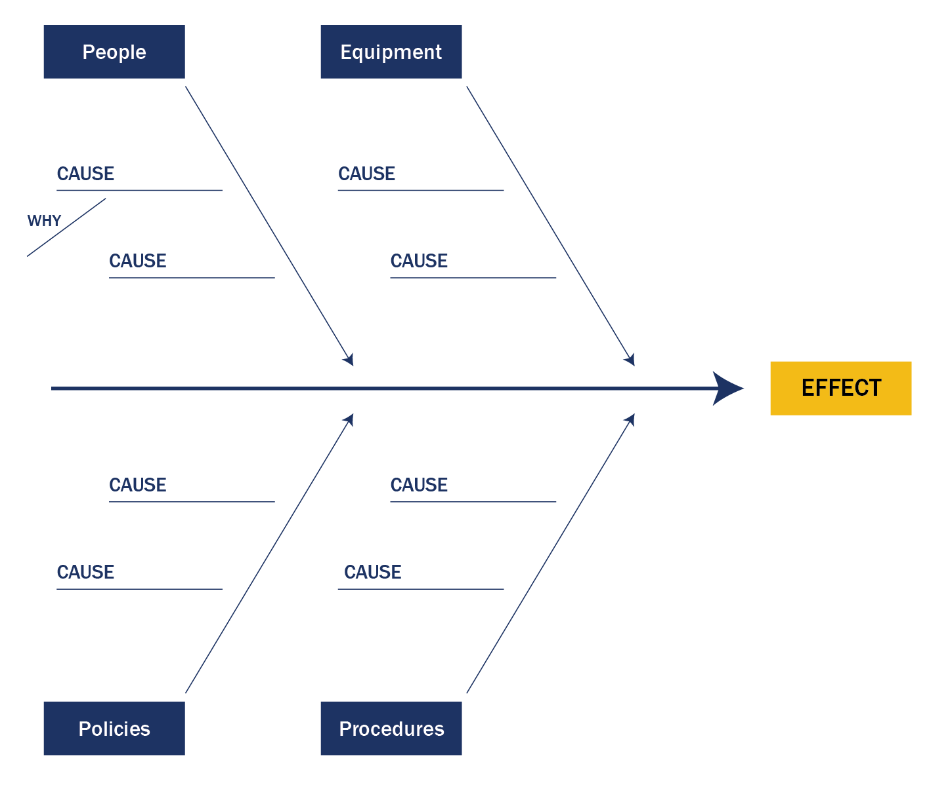

Five Whys Root Cause Analysis
This activity is often used for conducting a root cause analysis because it provides a layered approach to understanding a problem. The facilitator should provide a problem statement (or ask the group to provide such a statement) that is written on chart paper. Then, the facilitator will ask simply, “Why?” The facilitator will write “because” on the chart paper and summarize the group’s comments into a new statement. The facilitator will repeat this process three to five times until the group reaches consensus on the underlying cause or causes of the problem. There may be some diverse responses to the “Why?” questions. However, for each analysis, the group needs to focus on one response in order to dig deeper into the root cause of one statement. The facilitator can revisit alternative responses to conduct other analyses later, if he/she determines this is necessary.

Example of Five Whys Analysis
Problem Statement: Migratory children in our state are performing significantly lower in reading and math than other children even though they are provided supplemental services.
Why?
Because migratory children have high rates of absenteeism.
Why?
Because migratory children miss school due to illnesses.
Why?
Because migratory children don’t have easy access to medical care.
Why?
Because there are no medical services near where the families are living.
Why?
Because the area is too rural and population base too small to support a medical clinic.
Note how the process can lead to a very different view of why migratory children may not be performing well in school. The value of this process is to enable team members to consider other strategies beyond instructional solutions for poor academic performance and focuses attention on other issues that might have been overlooked.

SWOT (Strengths, Weaknesses, Opportunities, Threats) Analysis
A SWOT analysis is helpful in identifying a range of considerations that will facilitate or impede the attainment of outcomes as the team develops the plan. The facilitator should have four sheets of chart paper with the following headings: Strengths, Weaknesses, Opportunities, and Threats. After explaining the purpose of the activity to the team, the facilitator should provide a prompt to focus the discussion. An appropriate prompt could be “What are the most important considerations for our state plan to serve migratory children and youth?”
Then the facilitator will invite input from the group and capture ideas on the chart paper, beginning with Strengths.
The following questions will help elicit responses for each of the headings:
Strengths
- What are the best features of our migrant program that we can build on?
- What strengths exist among our migratory children and youth and their families?
Weaknesses
- What are the greatest areas of needed improvement in our MEP?
- Who or what agencies and programs need guidance and support to help achieve good educational outcomes for migratory children and youth?
Opportunities
- What untapped resources exist for migratory children, youth, and families in our state?
- Who are the leaders and champions of the MEP that we need to involve?
Threats
- What are the barriers to migratory children and youth succeeding in school?
- What will be the challenges to creating a plan that will achieve the Measurable Program Outcomes we desire for migratory children and youth?
Similar to brainstorming, the facilitator will want to keep the group energized and record all ideas quickly. Then, the group can prioritize the ideas by placing colored dots by the ideas that they feel are the most important. The facilitator should spend a few minutes debriefing and summarizing what was learned from the activity.

Think, Pair, Share
Think, Pair, Share is a technique that fosters individual reflection and group discussion on a topic.
Step 1. Provide a prompt, such as a statement, set of data, or article.
Step 2. Ask each individual to reflect on the statement and note ideas in writing. The facilitator should provide team members with a sheet of paper with questions to consider.
Step 3. Ask individuals to pair up and discuss their ideas. Pairs may represent similar roles or very different roles.
Step 4. After pairs have shared their ideas, ask for voluntary comments on what they have learned from each other. This sharing may generate further discussion on the topic that will provide insight into the MEP.

