Convening the NAC (Reference)
When the experts’ participation is arranged, you will likely want to arrange for the NAC to convene face-to-face, if possible. We suggest that the NAC meeting be divided into Expert Work Groups to analyze the needs more fully, determine if any root causes have been overlooked, and identify strategies that have proven effective in addressing the unique needs of migratory children in your state.
Figure 4.A.1 depicts a model for how Expert Work Groups can work in conjunction with the NAC, with discussions among the whole group and activities for each Expert Work Group targeted to the Need Statements most relevant to its area of expertise. It may work well to organize into breakout sessions in a “mini-conference” format.
Figure 4.A.1. Expert Work Groups Model
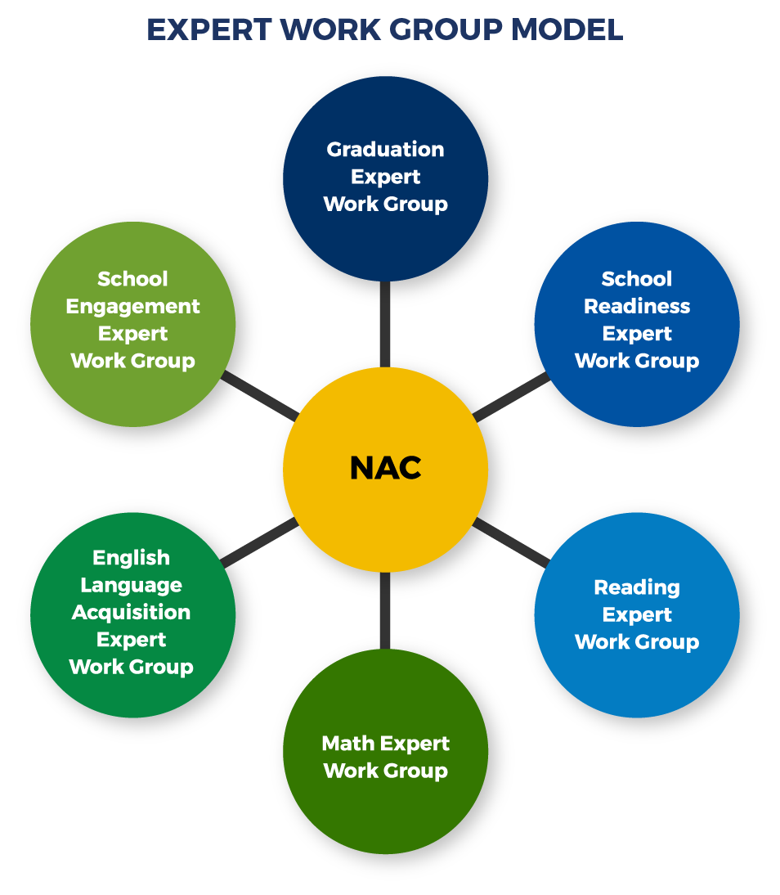

When you convene the NAC and experts, we recommend you clarify that the purpose of the meeting is to identify evidence-based and effective strategies to meet the priority needs. While some discussion of whether the strategies can be adapted to your state’s context is in order, you can clarify that planning the implementation of the strategies is the work of the Service Delivery Plan (SDP) team. The SDP team will take the work of the NAC and craft the strategies into an implementation plan.
Considerations for Small States
In small states, or in states where a face-to-face meeting is not feasible, a small group can be charged with developing criteria and arranging ways to obtain feedback from a larger group of stakeholders. We suggest that the small group comprise, at the very least, other state-level Program Managers who have experience prioritizing activities and tasks. Once the criteria have been set, you may identify certain stakeholders, such as regional or local Migrant Education Program (MEP) coordinators, parents, school district staff and program coordinators, or service providers, to give input on how to prioritize the proposed solutions. You may consider conducting an online survey or focus groups (perhaps at meetings these stakeholders attend or by phone), and then develop a final prioritized list based on the input you receive.
Since convening the Expert Work Groups means likely introducing new members of the NAC team, think about making time for introducing them and ensuring they feel ready to engage with the established group by reviewing the work of the NAC to date and how it relates to the larger CNA process.

