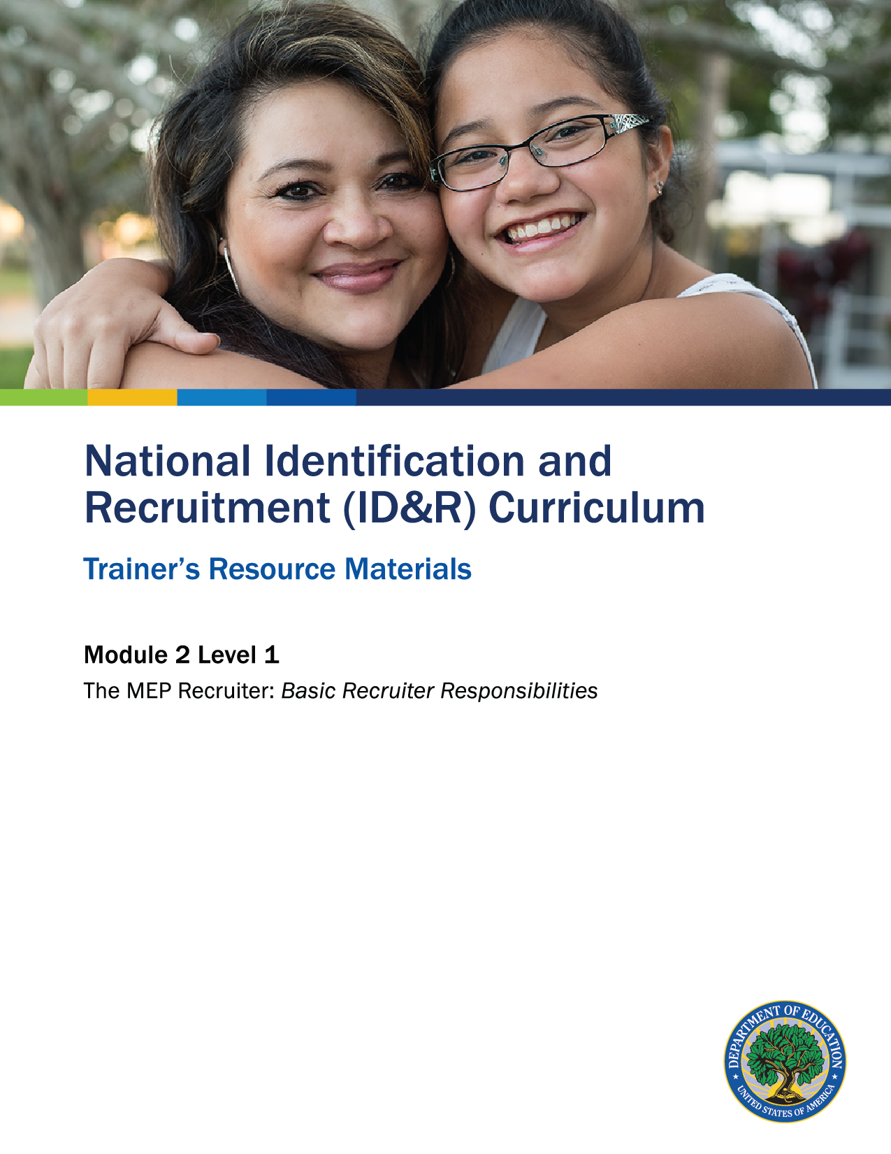

How to Use the Trainer’s Resource Materials
Name of Activity | Slide # | Title of Resource Page(s) | Page # | Prep Directions for  Resource Pages
Characteristics of Migratory Workers and Their Families | 5 | Migratory Workers and Their Families – Recording Sheet | 3 | One copy per small group
 |  | Migratory Workers and Their Families – Sample Key | 4 | Sample Key is for trainer only
What Am I  Responsible for? | 14 | Recruiter Responsibility Cards | 5 | One set of cut-apart cards run on cardstock per pair of participants

Migratory Workers and Their Families – Recording Sheet

Work with your group to determine the missing characteristic or cause.
Cause | Characteristic
May work 10–12 hour days in the field, in some cases 7 days per week. Few breaks are provided. May work additional jobs to support family.
 | Strong family relationships
 | English language deficiencies
May move 2–3 times in any given year following specific crops or in search of work.

Farming, ranching, and fishing does not pay well. In many instances, the crops fail, and there may be no paycheck. Weather can influence whether a worker is paid or not. Many migratory workers have no other work skills, so they depend on migratory work to support their families. Many live in substandard housing.
Cause | Isolation
 | Low levels of schooling

Migratory Workers and Their Families –
Sample Key

The characteristics and causes listed may be worded in many ways. Consider and discuss all responses provided by participants. (Have on hand a copy of the common characteristics listed in Chapter 1 of the National ID&R Manual as a reference.)
Cause | Characteristic
May work 10–12 hour-days in the field, in some cases 7 days per week. Few breaks are provided. May work additional jobs to support the family. | Hardworking
Many families work together in the fields. They depend on each other to make ends meet and complete family chores and responsibilities. | Strong family relationships
Many of our families do not speak English as their native language. Children are raised in households hearing little or no English. | English language deficiencies
May move 2–3 times in any given year following specific crops or in search of work. | High mobility
Farming, ranching, and fishing does not pay well. In many instances, the crops fail, and there may be no paycheck. Weather can influence whether a worker is paid or not. Many migratory workers have no other work skills, so they depend on migratory work to support their families. Many live in substandard housing. | Low income
Because they move so much, many families do not establish ties within the communities. Children may find it difficult to make friends because of late school enrollments (clubs are already formed, sports have started, etc.). | Isolation
Moving during the school year makes it difficult for students to keep up with the requirements of each grade level. Many end up dropping out of school due to frustration and failure. | Low levels of schooling

Recruiter Responsibility Cards

Becoming familiar with where migratory families live and work | Facilitating communication among migratory families, schools, agricultural employers, and the community | Explaining the  MEP to families  and youth | Implementing  quality control procedures
Collecting child  eligibility and  other basic  program data | Finding migratory children and their families and youth | Making preliminary determinations on child eligibility | Interviewing  migratory families
Understanding the federal and state MEP eligibility requirements | Documenting child eligibility accurately  and completely  when completing  a Certificate of Eligibility (COE) | Establishing and maintaining a recruitment network | Following ethical standards and confidentiality laws

Level 1: Assessment

Which of the following is not a responsibility of a recruiter? Circle your answer.
- Implementing quality control procedures
- Maintaining the confidentiality of the student and families
- Providing funds to migratory families in need
- Finding migratory children and their families and youth

- Making preliminary child eligibility determinations

List five characteristics of an effective recruiter.
1.
2.
3.
4.
5.

As a recruiter, you have many roles. Other than identifying and recruiting, which of the roles listed below would you say is most important? Why?
- Advocate

- Outreach worker

- School liaison

- Community liaison

Level 1: Assessment Key

Which of the following is not a responsibility of a recruiter? Circle your answer.
- Implementing quality control procedures
- Maintaining the confidentiality of the student and families
- Providing funds to migratory families in need (Correct Answer)
- Finding migratory families where they live and work
- Making preliminary child eligibility determinations

Remind participants that there is a list of key recruiter responsibility characteristics included in Chapter 2 of the National ID&R Manual.

List five characteristics of an effective recruiter.
Responses could vary. Refer to the list of characteristics your group created during the training. Remind participants that there is a list of effective recruiter characteristics included in Chapter 2 of the National ID&R Manual as well.

As a recruiter, you have many roles. Other than identifying and recruiting, which of the roles listed below would you say is most important? Why?
- Advocate

- Outreach worker

- School liaison

- Community liaison

Any role is acceptable as a response; justification must be provided.

