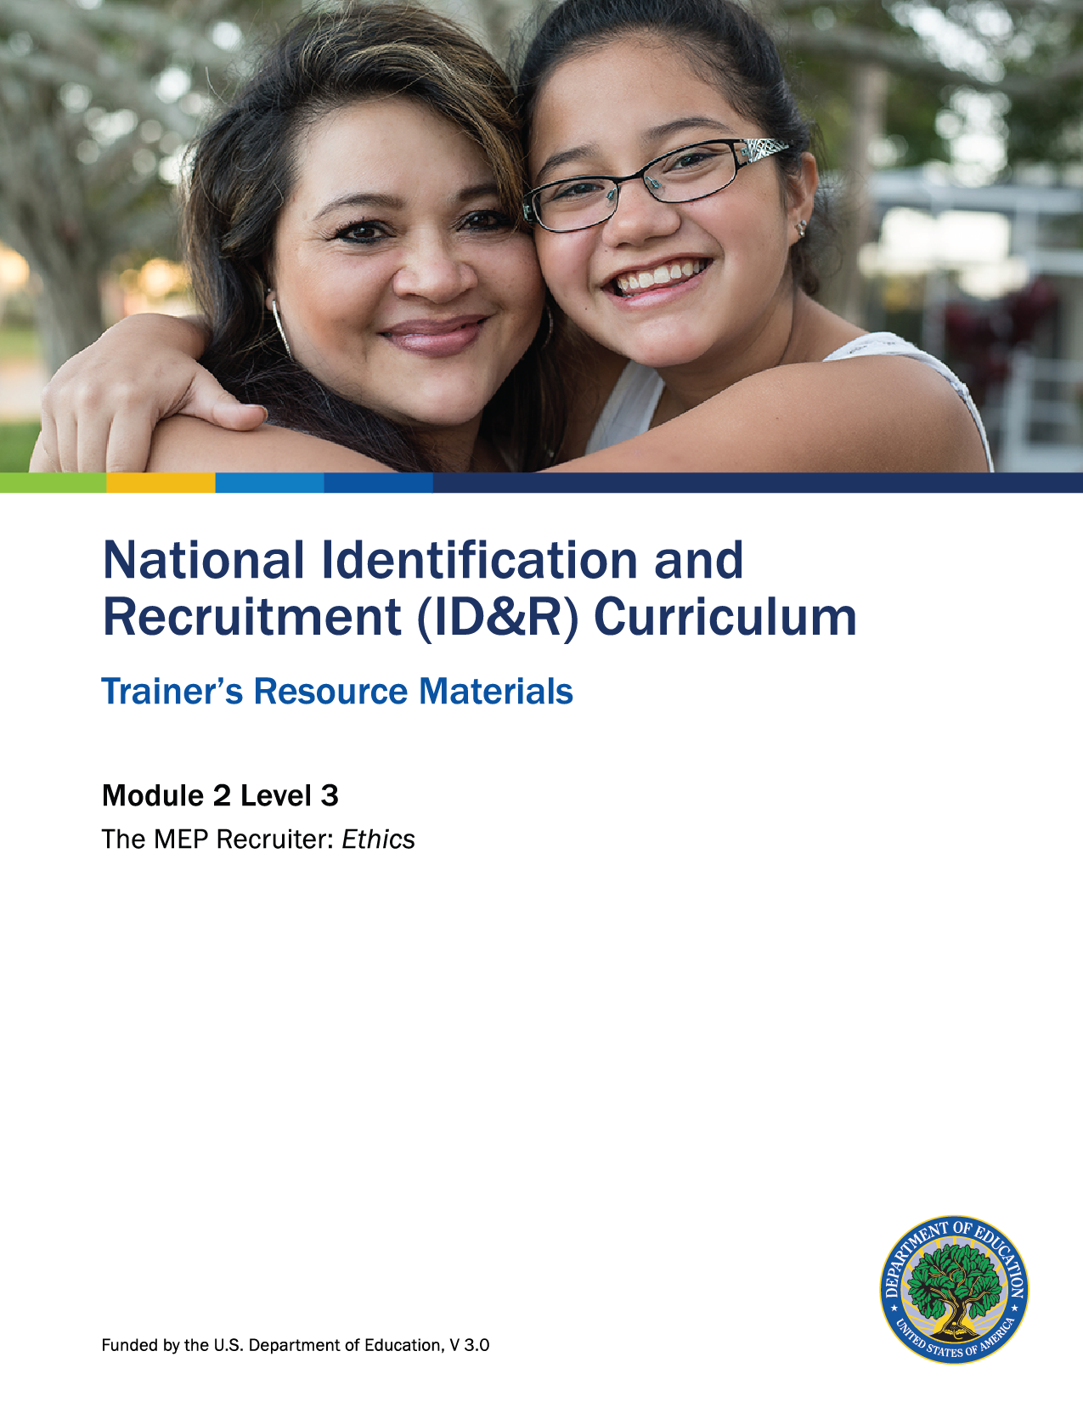

How to Use the Trainer’s Resource Materials
Name of Activity | Slide # | Title of Resource Page(s) | Page # | Prep Directions for  Resource Pages
Two Truths and a Lie | 6 | Two Truths and a Lie | 3 | One copy per pair of participants
 |  | Two Truths and a Lie – Key | 4 | One copy per participant
Ethical Issues and Solutions | 17 | Ethical Issues and Solutions:  Case Study 1  Case Study 2  Case Study 3 | 5  6  7 | One set printed on cardstock. Each case study should be taped to a large chart paper. The chart papers should be posted around the room. Based on the number of participants, the trainer may want to make duplicate sets of scenarios to allow for smaller groups at each case study.
 |  | Ethical Issues and Solutions:  Case Studies 1–3 – Key | 8  9  10 | Key is for trainer only
Level 3 Assessment | 23 | Level 3 Assessment and Key | 11, 12 | One copy per participant; Key is for trainer only

Two Truths and a Lie
Please identify the “lie” within each set of statements below.

Set #1
True | The recruiter’s primary responsibility is to properly identify and recruit migratory children for the MEP.

False
True | It is not the recruiter’s responsibility to report fraud within the MEP.

False
True | It is an expectation that the recruiter should have up-to-date knowledge of the rules  of eligibility established at both the federal and state levels.

False

Set #2
True | Recruiters should base their eligibility decisions on whether a family made a qualifying move, where the family moved to, and if the children in the family  deserve assistance.

False
True | Recruiters must not exaggerate, falsify, or omit information on any program documents.

False
True | Recruiters work with migratory farm workers and their families who often live in poverty and rural isolation, are highly mobile, and experience educational disruptions.

False

Two Truths and a Lie – Key
Please identify the “lie” within each set of statements below.

Set #1
True | The recruiter’s primary responsibility is to properly identify and recruit migratory children for the MEP.

False
True | It is not the recruiter’s responsibility to report fraud within the MEP.
False | False: It is the job of everyone in the MEP to protect the reputation and integrity of the MEP. It is everyone’s responsibility to report any fraud that they observe.
True | It is an expectation that the recruiter should have up-to-date knowledge of the rules of eligibility established at both the federal and state levels.

False

Set #2
True | Recruiters should base their eligibility decisions on whether a family made a qualifying move, where the family moved to, and if the children in the family  deserve assistance.
False | False: While eligibility decisions should be based on whether the move was a qualifying move and if the family moved across school district lines, other factors like whether a child deserves assistance should not be considered.
True | Recruiters must not exaggerate, falsify, or omit information on any program documents.

False
True | Recruiters work with migratory farm workers and their families who often live in poverty and rural isolation, are highly mobile, and experience educational disruptions.

False

Ethical Issues and Solutions
Case Study 1

A local recruiter, Francisco Díaz, has been working in the MEP for fifteen years. He is well liked throughout the community and works well with all of the agencies serving migratory families. Just recently, he received a community award for setting up a food drive during the holiday season. During September of last year, many migratory families moved into the area to harvest apples. The children of the migratory families were identified and recruited into the MEP program, thus were eligible to receive educational and support services. During the data entry process, the records clerk noticed three COEs listing children from longtime families she knows have never left the community. She brought this concern up to Francisco’s attention. Francisco said that the children need the educational services and to leave them as eligible. The data clerk didn’t agree and took the issue to Francisco’s supervisor. The supervisor told the data clerk to leave the issue alone since no one will know the difference if the children are eligible or not. The data clerk is not happy with the decision but is reluctant to say anything to upset Francisco or her supervisor.

Which Recruiter Standard of Conduct is addressed?

What are the ethical issues in this scenario?

What are the possible solutions?

Ethical Issues and Solutions
Case Study 2
In the last couple of years, the number of eligible migratory children in the State has dropped, and allocations to each of the districts have been lowered. The Calibri Valley District has begun to panic as they see their student numbers drop, allocations lowered, and highly qualified staff taking other jobs. The district leadership decides to evaluate the situation and do something about its identification and recruitment program. The district coordinator introduces a new incentive program in the fall. Each recruiter will need to identify 25 new students, over and above last year’s numbers. The district says this proposed plan will increase student enrollment and guarantee their jobs, and the recruiter who identifies the most students will go to the National Migrant Education Conference in the spring. The district incentive brings a lot of excitement, enthusiasm, and competition among some of the recruiters.

Which Recruiter Standard of Conduct is addressed?

What are the ethical issues in this scenario?

What are the possible solutions?

Ethical Issues and Solutions
Case Study 3
Jake Lamada is a well respected recruiter at Middleton Unified School District. Angela Sanchez is also a recruiter with Middleton Unified School District and is assigned to Drywood Elementary. Jake was instructed by his supervisor to look into concerns by other migratory education staff regarding the eligibility status of some migratory families in the district. Angela’s campus, Drywood Elementary, has a long history of migratory children withdrawing from school in December to travel to Mexico and then re-enrolling in the school two or three weeks later. Angela has been with the district for fifteen years and, due to her popularity and experience with the MEP, is very well known within the migrant community. Jake met with MEP staff and began reviewing all COEs from Drywood Elementary. He reviewed the number of students that were withdrawn from school in December and re-enrolled two or three weeks later. He noticed that a small number of COEs with a new Qualifying Arrival Date (QAD) were completed for a few migratory families. Jake is informed by MEP staff that the migratory families who were given a new QAD were personal friends of Angela’s. After further investigation, some of the new COEs were found to be ineligible in establishing a new QAD.

Which Recruiter Standard of Conduct is addressed?

What are the ethical issues in this scenario?

What are the possible solutions?

Ethical Issues and Solutions: Case Studies 1–3 – Key
Answers to Case Study 1

Recruiter Standard of Conduct

Know the eligibility rules, be objective, be honest, report fraud

Ethical issues

The data specialist is trying to do the right thing. The recruiter and supervisor are
trying to help ineligible students.

Francisco is trying to earn community respect and feel good about helping people. He
is ignoring the legal guidelines and breaking the law by not adhering to proper legal
use of funds.

The supervisor does not want to “cause trouble” or correct the problem.

Possible solutions

The data specialist can contact the State MEP Director, the Office of Migrant Education, or the Office of Inspector General.

Francisco needs to acknowledge that these children are not eligible for the program
and follow the rules.

The supervisor needs to correct the COEs and notify the State MEP that the COEs must be removed from the child count.
Answers to Case Study 2

Recruiter Standard of Conduct

Know the eligibility rules, be objective, be honest, report fraud

Ethical issues

The district coordinator’s incentive policy could lead to ineligible children being signed
up for the MEP.

Questions could arise as to whether this information is accurate and truthful.

The state might receive funding for these ineligible children, and using those funds
for ineligible children would violate the law.

Recruiters would see their job as a way to earn “free” vacations.

Possible solutions

It is the recruiter’s responsibility to only identify eligible children.

If the recruiter believes that others are seeking “personal gain” by creating false
documents, they can call the fraud hotline.

Ethical Issues and Solutions: Case Studies 1–3 – Key
Answers to Case Study 3

Recruiter Standard of Conduct

Know the eligibility rules, be objective, be honest, report fraud

Ethical issues

The recruiter is falsifying information by extending the period of eligibility for some families
but not for all.

Given the comments from migrant staff, questions can arise as to whether the new
information is accurate and truthful.

Possible solutions

Jake should sit down with the recruiter and clarify the information. If the families are, in fact, eligible then the recruiter needs to correctly document the information for other families in
the same situation. If they are not eligible, the recruiter needs to remove the students from the
computer system and report them as not eligible.

The state may re-interview the families to determine what information is correct.

Level 3: Assessment

1. Define “ethics.”

2. List two or three reasons why it is important to maintain high ethical standards.

3. Identify the four elements in the MEP standards of conduct.

Level 3: Assessment Key

1. Define ethics.

Answers could include (http://www.merriam-webster.com/dictionary/ethics):

A discipline dealing with what is good and bad and with moral duty and obligation

The principles of conduct governing an individual or a group

A guiding philosophy

A consciousness of moral importance

2. List two or three reasons why it is important to maintain high ethical standards.

Answers could include:

Establish trust

Adhere to guidelines

Ensure everyone is treated fairly and justly

Maintain high expectations

Develop accountability

Build trust and respect

3. Identify the four elements in the MEP standards of conduct.

Answers are:

Know the eligibility rules

Be objective

Be honest

Report fraud

