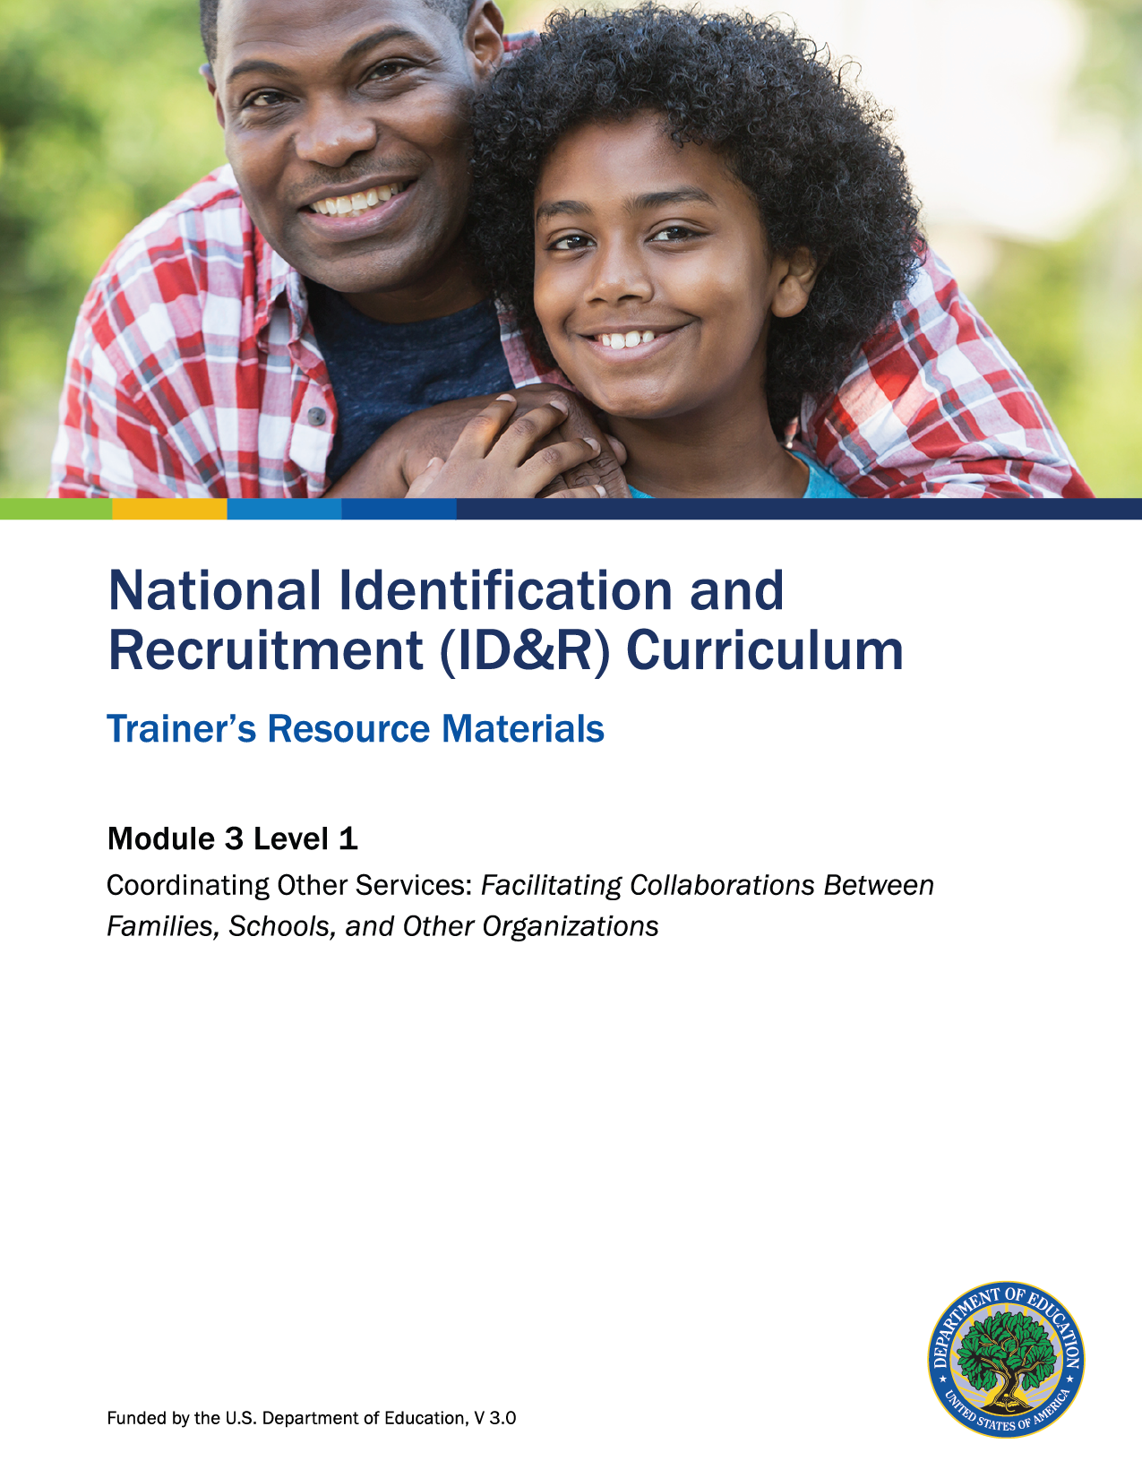

How to Use the Trainer’s Resource Materials
Name of Activity | Slide # | Title of Resource Page(s) | Page # | Prep Directions for  Resource Pages
Local, State, and Federal Services Carousel Debrief | 12 | Sample of Federal Services | 3 | One copy per participant.
Families in Need Part 1 | 16 | Families in Need | 6 | One copy per participant.
Level 1 Assessment | 19 | Level 1 Assessment and Key | 7–8 | One copy of the assessment per participant; Key is for trainer only.

Sample of Federal and National Services
Service |  |  | Description
National School Lunch Program (NSLP) |  | Provides nutritionally balanced, low-cost or free lunches to children each school day.  https://www.fns.usda.gov/cnd/Lunch
Women, Infants, and Children (WIC) |  | Provides grants for supplemental foods, health care referrals, and nutrition education for low-income pregnant and recently pregnant women and to infants and children at nutritional risk up to age five.  https://www.fns.usda.gov/wic
Child Nutrition Program |  | Serves children who are enrolled in child care, attending after-school care programs, or residing in emergency shelters.  https://www.fns.usda.gov/school-meals/child-nutrition-programs
National Center for Farmworker Health (NCFH) |  | Improves the health status of farmworker families by providing services and products to a network of more than 500 migrant health center service sites.  http://www.ncfh.org
Migrant Health Program |  | Provides grants to community-based non-profit organizations to offer a broad array of culturally and linguistically competent medical and support services to migratory and seasonal farmworkers and their families, including both primary and preventative health care.  https://www.farmworkerjustice.org/content/migrant-health-centers
Occupational Safety and Health Administration (OSHA) |  | Trains farmworkers in issues such as safety and pesticides. Provides assistance to growers using the guest worker programs. Provides regulations on migrant housing. Provides lists of migrant housing and camps.  https://www.osha.gov

Sample of Federal and National Services (continued)
Service |  |  | Description
National Migrant & Seasonal Head Start Association (NMSHSA) |  | Partners with member agencies to provide education, health, disability, nutrition, parent involvement, and social services to qualifying migratory children and their families.  http://www.nmshsa.com
College Assistance Migrant Program (CAMP) |  | Assists migratory and seasonal farmworkers and their immediate family members in successfully completing the first undergraduate year of study in a college or university and provides follow-up services to help students continue in postsecondary education.  http://www.hepcampassociation.org
High School Equivalency Program (HEP) |  | Helps migratory and seasonal farmworkers (or children of such workers) who are 16 years of age or older and not currently enrolled in school to obtain the equivalent of a high school diploma and, subsequently, to gain employment or begin postsecondary education or training.  http://www.hepcampassociation.org
Temporary or Seasonal Agricultural Work Certification Program (H-2A) |  | Allows employers to hire temporary or seasonal foreign workers when there is a shortage of U.S. workers who are able, willing, qualified, and available. Certification that applicable conditions have been met is required before a foreign worker can be brought to the United States on an employment–based visa.  https://www.foreignlaborcert.doleta.gov/h-2a.cfm
National Farmworkers Jobs Program  (NFJP) |  | Authorized by Section 167 of the Workforce Investment Act, provides job training and employment assistance for legally residing migratory and other seasonally employed farmworkers and their families. Services may be obtained through the DOL’s local One-Stop Career Centers. The NFJP program is administered by community-based grantee organizations. Each grantee has one or more outreach workers.  https://www.doleta.gov/Farmworker

Sample of State and Local Services
Service |  |  | Description

Families in Need, Part 1

Read each family situation.

Use your lists of local, state, and federal services to determine which might meet the needs
of the family; record.

The Dominguez Family
Mrs. Dominguez and her three children, Geneva (17), Bobby (12), and Dionicia (3) have qualified for the MEP. Geneva failed her freshman year twice and is in 9th grade again this year; Bobby has started to struggle in school, and his teachers are thinking he may have difficulty seeing the board in the classroom. Dionicia goes with Mrs. Dominguez to her part-time job cleaning houses. Mrs. Dominguez struggles to make ends meet, since she’s only able to migrate during the summer and school vacations.

Which local, state, and federal services might be needed by the family?

The Cabello Family
Mr. and Mrs. Cabello and their two children, Frances (20) and Jorge (15) have qualified for the MEP. Mr. and Mrs. Cabello only speak Spanish and moved to the United States with the children four years ago. Frances has not graduated from high school and is considering dropping out, since she’s an over-age senior. Both children have struggled in school, and their mother strongly believes it’s because they do not speak or understand English well. Frances also has been suffering from migraines lately, and Mrs. Cabello is quite concerned about her, yet doesn’t know what she can do to help her. Mr. Cabello typically only does migrant work outside the state, but their car has started to act up, so he’s hoping to find any type of work nearby.

Which local, state, and federal services might be needed by the family?
- The Moreno Family
Mr. and Mrs. Moreno typically migrate with their six grandchildren, ages 4–12. As of last year, all the children reside with the grandparents year-round. Mrs. Moreno has informed you that the oldest child, Manuel, was abused when he was younger and has been getting into trouble at school lately for acting up. Though the family has not asked for much from the MEP, you have been told by the teachers at school that the kids wear clothing that’s either too tight or way too big, and they all are in desperate need of new shoes. The school nurse has also informed Mrs. Moreno that two of the children are due for immunizations, something she hasn’t had to deal with for quite a few years.

Which local, state, and federal services might be needed by the family?

Level 1: Assessment

1. Why is it important to advocate for migratory families?

2. Place a check by each of the categories below that have local, state, or federal programs available for migratory families.
____ 1. Child care
____ 2. Nutrition
____ 3. Playground equipment safety
____ 4. Health care
____ 5. Organizing school functions
____ 6. Utilities
3. Name three organizations specific to your area and note what services they provide.
- ____________________________________________________________________________________________________________________________________________________________________
- ____________________________________________________________________________________________________________________________________________________________________
- ____________________________________________________________________________________________________________________________________________________________________

Level 1: Assessment Key

1. Why is it important to advocate for migratory families?
Responses could include:
- Many families cannot communicate with school personnel/outside agencies due
to language barriers.
- Families are not aware of specific services available for a particular need.
- Many parents work long hours, making it difficult for them to contact agencies/
organizations during regular business hours.

2. Place a check by each of the categories below that have local, state, or federal programs available for migratory families.
1. Child care
2. Nutrition
3. Playground equipment safety
4. Health care
5. Organizing school functions
6. Utilities
3. Name three organizations specific to your area and note what services they provide.
Answers will vary depending on organizations found in the participant’s area.
Accept all reasonable responses.

