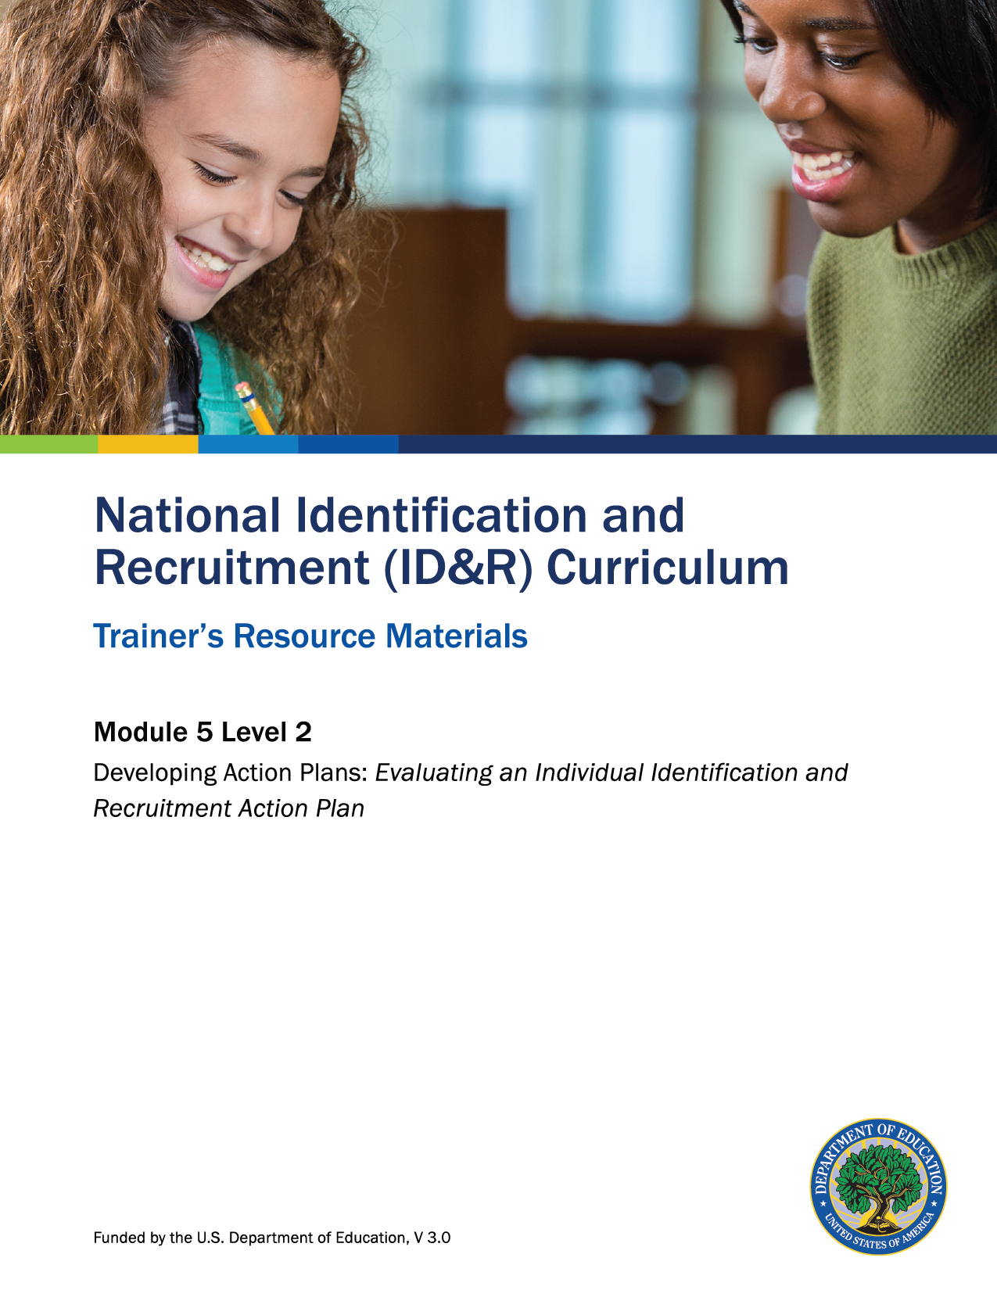

How to Use the Trainer’s Resource Materials
Name of Activity | Slide # | Title of Resource Page(s) | Page # | Prep Directions for  Resource Pages
Evaluation Questions: Individual ID&R Action Plan | 8 | Action Plan Evaluation Questions | 3 | Use a poster-maker to enlarge template to post in room during session.
Level 2: Assessment | 14 | Level 2: Assessment and Key | 4–5 | One copy per participant; Key is for trainer only.

Action Plan Evaluation Questions

Is the objective still valid? Have circumstances changed that would necessitate the need for the objective to be modified or deleted?

Is the appropriate staff responsible for this objective?

Is this the appropriate activity for the objective?

Does the objective have a realistic deadline? Are there other activities that may support this objective?

Is the evidence of success valid?

Level 2: Assessment

Name an objective that should never be included in the individual ID&R action plan.

List three questions you could use to evaluate the effective implementation of an individual ID&R action plan.

Level 2: Assessment Key

Name an objective that should never be included in the individual ID&R action plan.
Accept all responses that indicate objectives should not include recruitment quotas.

List three questions you could use to evaluate the effective implementation of an individual ID&R action plan.
Accept any of the following responses.

1. Is the objective still valid? Have circumstances changed that would necessitate the need
for the objective to be modified or deleted?
2. Is the appropriate staff responsible for this objective?
3. Is this the appropriate activity for the objective? Are there other activities that may support
this objective?
4. Does the objective have a realistic deadline?
5. Is the evidence of success valid?

