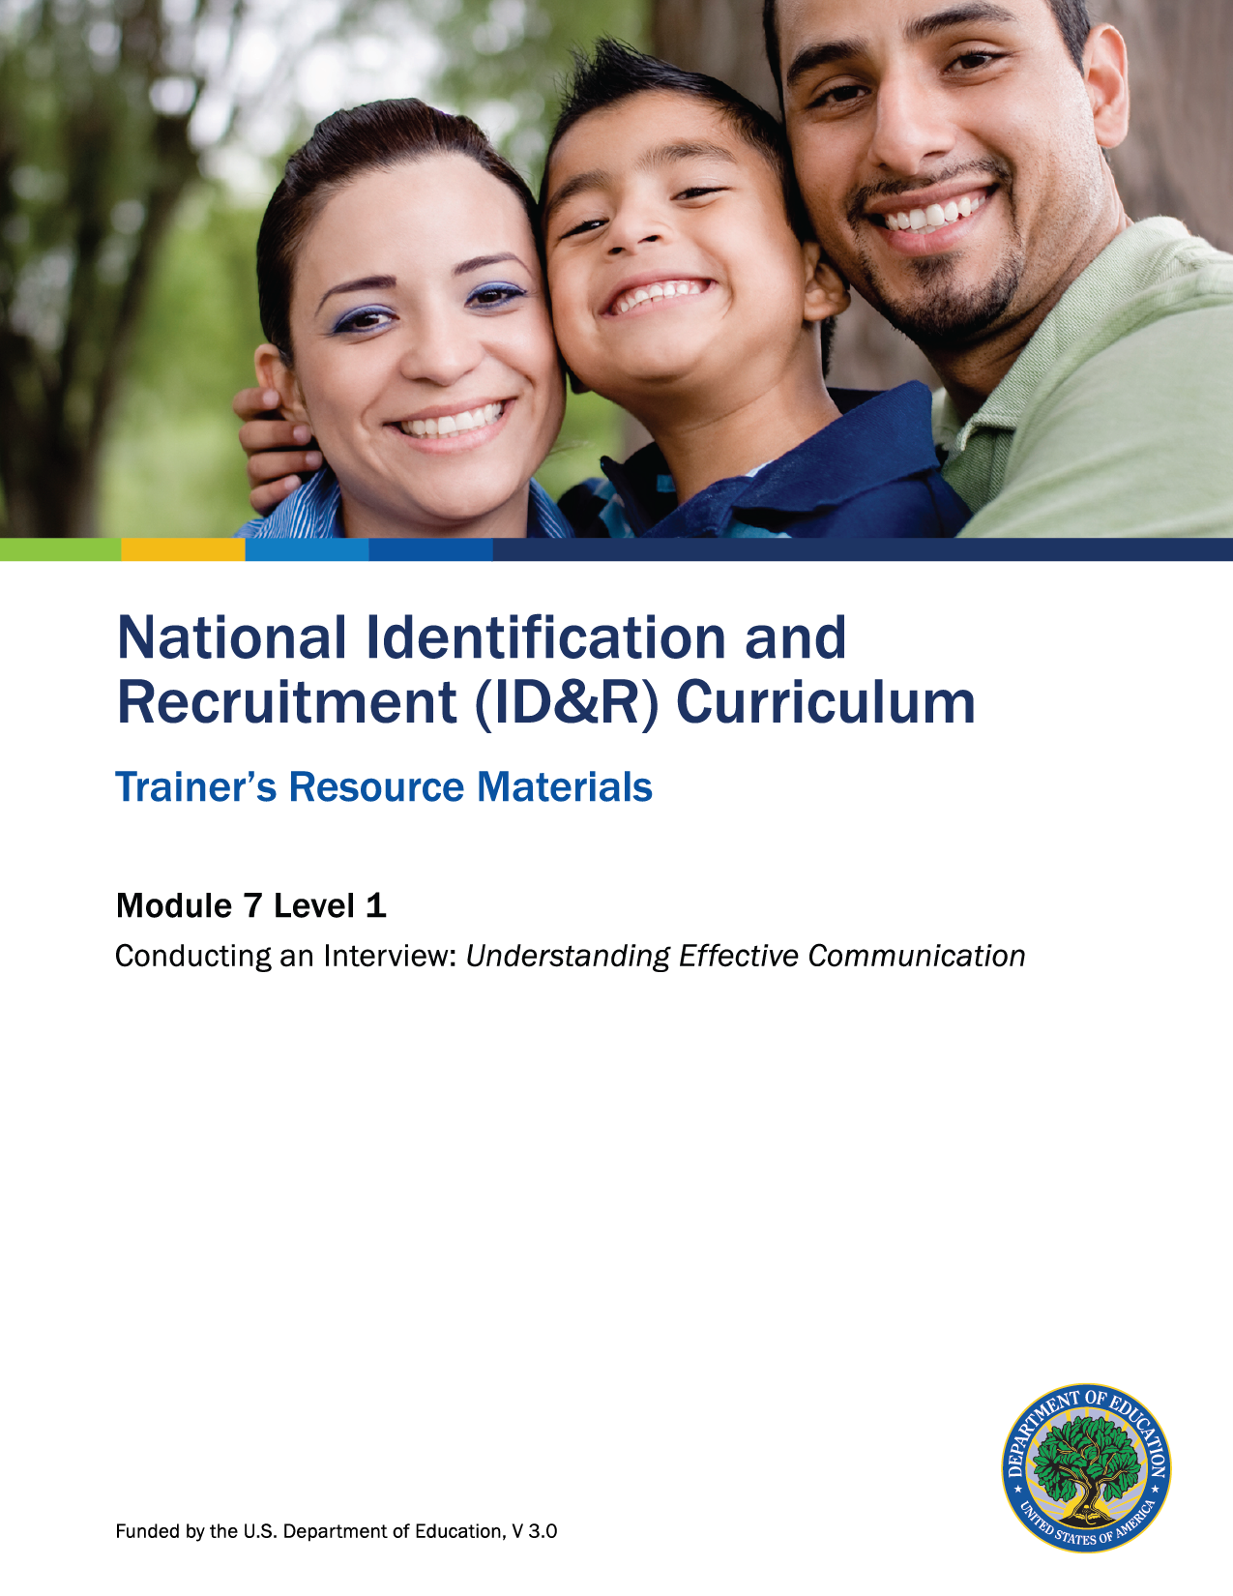

How to Use the Trainer’s Resource Materials
Name of Activity | Slide # | Title of Resource Page(s) | Page # | Prep Directions for  Resource Pages
MEP Categories | 8 | MEP Categories Statement Cards | 4–10 | Duplicate statements onto cardstock. Make one set of cards so each participant will have at least one card. There are 20 cards in total.  If you have 19 participants or less you may give some participants two cards so that all cards will be placed on the graphic organizer.  If you have more than 20 participants, have them work in pairs. Each pair will receive at least one card.
MEP Categories MEP Debrief | 10 | MEP Categories – Key | 11 | One copy per participant
Communication Activity | 21  29 | Iceberg Concept of Culture  Communication Activity  Parent Character Cards | 12  13–14 | One copy per participant  Duplicate each page onto a different colored cardstock. There are two copies per page. Cut cards apart to provide one per participant who will be role-playing the part of the parent.
 |  | Recruiter Task Card | 15 | Duplicate cards onto cardstock. There are two copies per page. Cut cards apart to provide one per participant who will be role-playing the part of the recruiter.
 |  | Observer Card | 16 | Duplicate cards onto cardstock. There are two copies per page. Cut cards apart to provide one per participant who will be the observer for the group.
Level 1: Assessment | 32 | Level 1: Assessment and Key | 17–18 | One copy per participant; Key is for trainer only.

MEP Categories Statement Cards

Assist States in supporting high-quality, comprehensive educational programs and services, during the school year and, as applicable, during summer or intercession periods, that address the unique educational needs of migratory children.
Ensure that migratory children who move among the states are not penalized in any manner by disparities among the states in curriculum, graduation requirements, and challenging state academic standards.
Ensure that migratory children receive full and appropriate opportunities to meet the same challenging state academic standards that all children are expected to meet.

Help migratory children overcome educational disruption, cultural and language barriers, social isolation, various health-related problems, and other factors that inhibit their ability to succeed in school.
Help migratory children benefit from state and local systemic reforms.
Individual and small group tutoring by special teachers, tutors, and aides to help students in their weak academic areas.
Transfer of student educational records when a child moves.
English as a Second Language classes
Adult Basic Education classes
Referrals to community services
Summer, youth leadership, and other academic enrichment programs
Supportive health services, including medical, dental, nutritional, and psychological services,
in cooperation with other agencies
CHILD’S AGE: The child is younger than 22 years old on the date of the interview.
CHILD’S SCHOOL COMPLETION STATUS: The child is entitled to a free public education through grade 12 under state law, or the child is not yet at a grade level at which the school district provides free education
MIGRATORY AGRICULTURAL WORKER’S OR MIGRATORY FISHER’S (MAW/MF) QUALIFYING MOVE: The parent/guardian/spouse or child (if the child is the worker) moved within the 36 months preceding the date of the interview, AND the move made by the parent/guardian/ spouse or child (if the child is the worker) was due to economic necessity, AND from one residence to another residence, AND from one school district to another.
QUALIFYING WORK: After the qualifying move, the parent/guardian/spouse or child (if the child is the worker) engaged in new qualifying work soon after the move.
QUALIFYING WORK: After the qualifying move, the parent/guardian/spouse or child (if the child is the worker) did NOT engage in new qualifying work soon after the move, but he or she actively sought new qualifying work, AND has a recent history of moves for qualifying work.
QUALIFYING WORK: The qualifying work is seasonal employment, OR temporary employment, OR personal subsistence. The qualifying work is agricultural OR fishing.
CHILD’S QUALIFYING MOVE RELATIVE TO THE MIGRATORY AGRICULTURAL WORKER OR FISHER: The child’s QUALIFYING MOVE was with, to join, or to precede a parent, guardian, or spouse.
CHILD’S QUALIFYING MOVE: The child moved within the 36 months preceding the date of the interview. The move was due to economic necessity, AND from one residence to another residence, AND from one school district to another.

Assist States in supporting high-quality, comprehensive educational programs and services, during the school year and, as applicable, during summer or intercession periods, that address the unique educational needs of migratory children.  Ensure that migratory children who move among the states are not penalized in any manner by disparities among the states in curriculum, graduation requirements, and challenging state academic standards.  Ensure that migratory children receive full and appropriate opportunities to meet the same challenging state academic standards that all children are expected to meet.  Help migratory children overcome educational disruption, cultural and language barriers, social isolation, various health-related problems, and other factors that inhibit their ability to succeed in school.  Help migratory children benefit from state and local systemic reforms. | FACTOR 1: CHILD’S AGE  The child is younger than 22 years old on the date of the interview.  FACTOR 2: CHILD’S SCHOOL COMPLETION STATUS  - The child is entitled to a free public education through grade 12 under state law, OR  - The child is not yet at a grade level at which the school district provides a free education.  FACTOR 3a: CHILD’S QUALIFYING MOVE (if the child’s move is not the same as the migratory agricultural worker or fisher)  - The child moved within the 36 months preceding the date of the interview.  - The move made by the child was due to economic necessity, AND from one residence to another residence, AND from one school district to another.  FACTOR 3b: CHILD’S QUALIFYING MOVE RELATIVE TO THE MIGRATORY AGRICULTURAL WORKER OR FISHER  - The child’s QUALIFYING MOVE in FACTOR 3a was as a migratory agricultural worker or migratory fisher, or was made with, to join or to precede a parent, guardian, or spouse who is a migratory agricultural worker or a migratory fisher (as determined in Factors 4a and 4b).  FACTOR 4a: MIGRATORY AGRICULTURAL WORKER’S OR MIGRATORY FISHER’S QUALIFYING MOVE  - The parent/guardian/spouse or child (if the child is the worker) moved within the 36 months preceding the date of the interview.  - The move made by the parent/guardian/spouse or child (if the child is the worker) was due to economic necessity, AND from one residence to another residence, AND from one school district to another.  FACTOR 4b: QUALIFYING WORK FOR THE MIGRATORY AGRICULTURAL WORKER OR FISHER  - After the QUALIFYING MOVE in Factor 4a, the parent/guardian/spouse or child (if the child is the worker):  - engaged in new QUALIFYING WORK (QW) soon after the move, OR  - did not engage in new QW soon after the move, but he or she  - actively sought new QW, AND  - has a recent history of moves for QW. | Individual and small group tutoring by special teachers, tutors, and aides to help students in their weak academic areas.  Transfer of student educational records when a child moves.  Summer, youth leadership, and other academic enrichment programs.  English as a Second Language classes.  Adult Basic Education classes.  Referrals to community services.  Supportive health services including medical, dental, nutritional and psychological services in cooperation with other agencies.

MEP Categories Statement Cards – Key
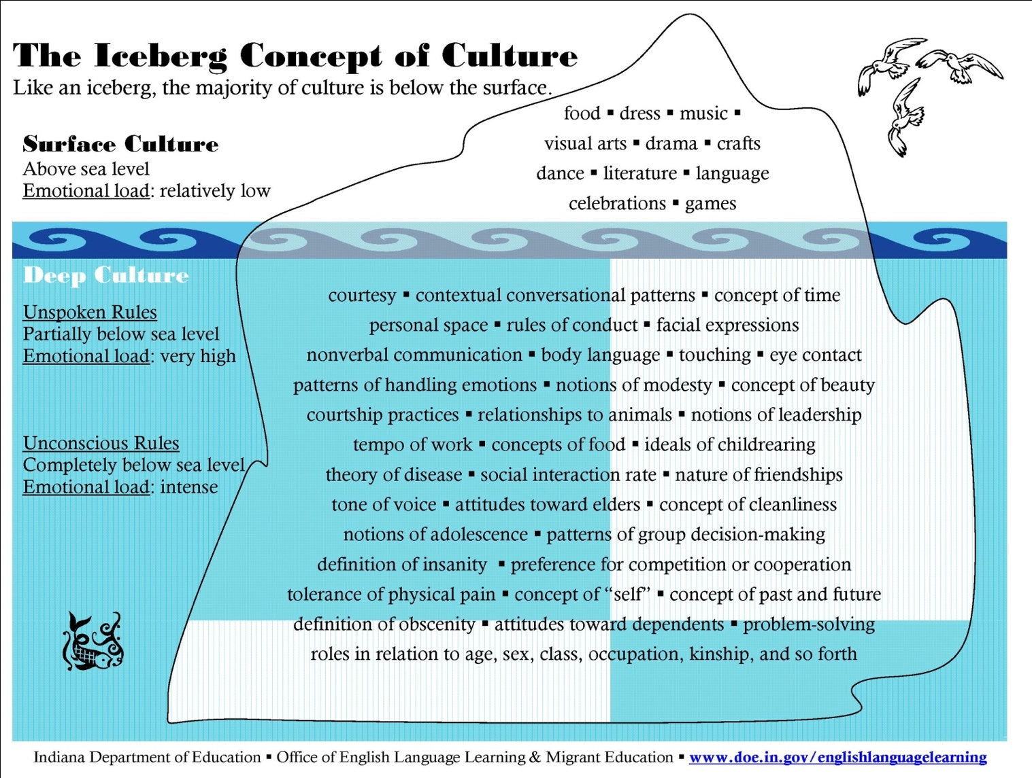

Communication Activity Parent Character Cards

Character A: You are very guarded when it comes to discussing yourself. You do not believe in volunteering personal information until you have established deep, meaningful relationships with others. Therefore, in conversations, you offer limited information about yourself, and in response to probing questions you frequently change the subject to safe topics, like the weather. You would never discuss your emotions with others, much less strangers, and would perceive someone doing so as shameless and aggressive.
Character A: You are very guarded when it comes to discussing yourself. You do not believe in volunteering personal information until you have established deep, meaningful relationships with others. Therefore, in conversations, you offer limited information about yourself and in response to probing questions you frequently change the subject to safe topics, like the weather. You would never discuss your emotions with others, much less strangers, and would perceive someone doing so as shameless and aggressive.

Communication Activity Parent Character Cards

Character B: It is customary for you to frequently interrupt people as they talk and to talk about yourself. You think that interrupting is part of a lively, dynamic, fast-paced conversation that engages everyone in the dialogue. You are very friendly, talk a lot and feel comfortable sharing very personal information right away with strangers. You feel free to express your emotions with others, using hand gestures and facial expressions. You think being expressive, emotionally and physically, during conversation is friendly and engaging and those who do not do so are secretive and detached.
Character B: It is customary for you to frequently interrupt people as they talk and to talk about yourself. You think that interrupting is part of a lively, dynamic, fast-paced conversation that engages everyone in the dialogue. You are very friendly, talk a lot and feel comfortable sharing very personal information right away with strangers. You feel free to express your emotions with others, using hand gestures and facial expressions. You think being expressive, emotionally and physically, during conversation is friendly and engaging and those who do not do so are secretive and detached.

Communication Activity Recruiter Task Card

Recruiter Task Card
You received information from your school district that a parent may be a migratory worker. You are meeting this parent for the very first time at your office; she does not have a phone so you sent a note home to arrange the meeting. Your task is to establish rapport with the parent and try to determine if she truly is migratory. In your conversation, please make sure to provide the parent with information about the MEP and ask the following questions in your own words:
- Have you or your husband ever moved across school district lines for seasonal OR
temporary work?

- Do you have children under the age of 22, and do they travel with you in seeking
this type of work?

- Have you ever been identified by the MEP in another school district?

Recruiter Task Card
You received information from your school district that a parent may be a migratory worker. You are meeting this parent for the very first time at your office; she does not have a phone so you sent a note home to arrange the meeting. Your task is to establish rapport with the parent and try to determine if she truly is migratory. In your conversation, please make sure to provide the parent with information about the MEP and ask the following questions in your own words:
- Have you or your husband ever moved across school district lines for seasonal OR
temporary work?

- Do you have children under the age of 22, and do they travel with you in seeking
this type of work?

- Have you ever been identified by the MEP in another school district?

Communication Activity Observer Card

Observer Card
Listen to the conversation between the recruiter and parent. As you listen, answer the following questions:

- How did the recruiter introduce himself or herself?

- Do you think the parent felt at ease? What made you think so?

- What strategies did you hear the recruiter using to get the necessary information? Did it work?

Observer Card
Listen to the conversation between the recruiter and parent. As you listen, answer the following questions:

- How did the recruiter introduce himself or herself?

- Do you think the parent felt at ease? What made you think so?

- What strategies did you hear the recruiter using to get the necessary information? Did it work?

Level 1: Assessment
1. What are the three steps to the communication process?
2. What is one of the purposes of the MEP?
3. Name a communication barrier discussed during the training and a strategy you would use to overcome that barrier.

Level 1: Assessment Key
1. What are the three steps to the communication process?
- Message we want to convey
- How we want to convey that message
- Message recipient receives
2. What is one of the purposes of the MEP?
Accept any of the following responses.
- Assist States in supporting high-quality, comprehensive educational programs and services, during the school year and, as applicable, during summer or intercession periods, that address the unique educational needs of migratory children.
- Ensure that migratory children who move among the states are not penalized in any manner by disparities among the states in curriculum, graduation requirements, and challenging state academic standards.
- Ensure that migratory children receive full and appropriate opportunities to meet the same challenging state academic standards that all children are expected to meet.
- Help migratory children overcome educational disruption, cultural and language barriers, social isolation, various health-related problems, and other factors that inhibit their ability to succeed in school.
- Help migratory children benefit from state and local systemic reforms.
3. Name a communication barrier discussed during the training and a strategy you would use to overcome that barrier.
Accept all reasonable responses.

