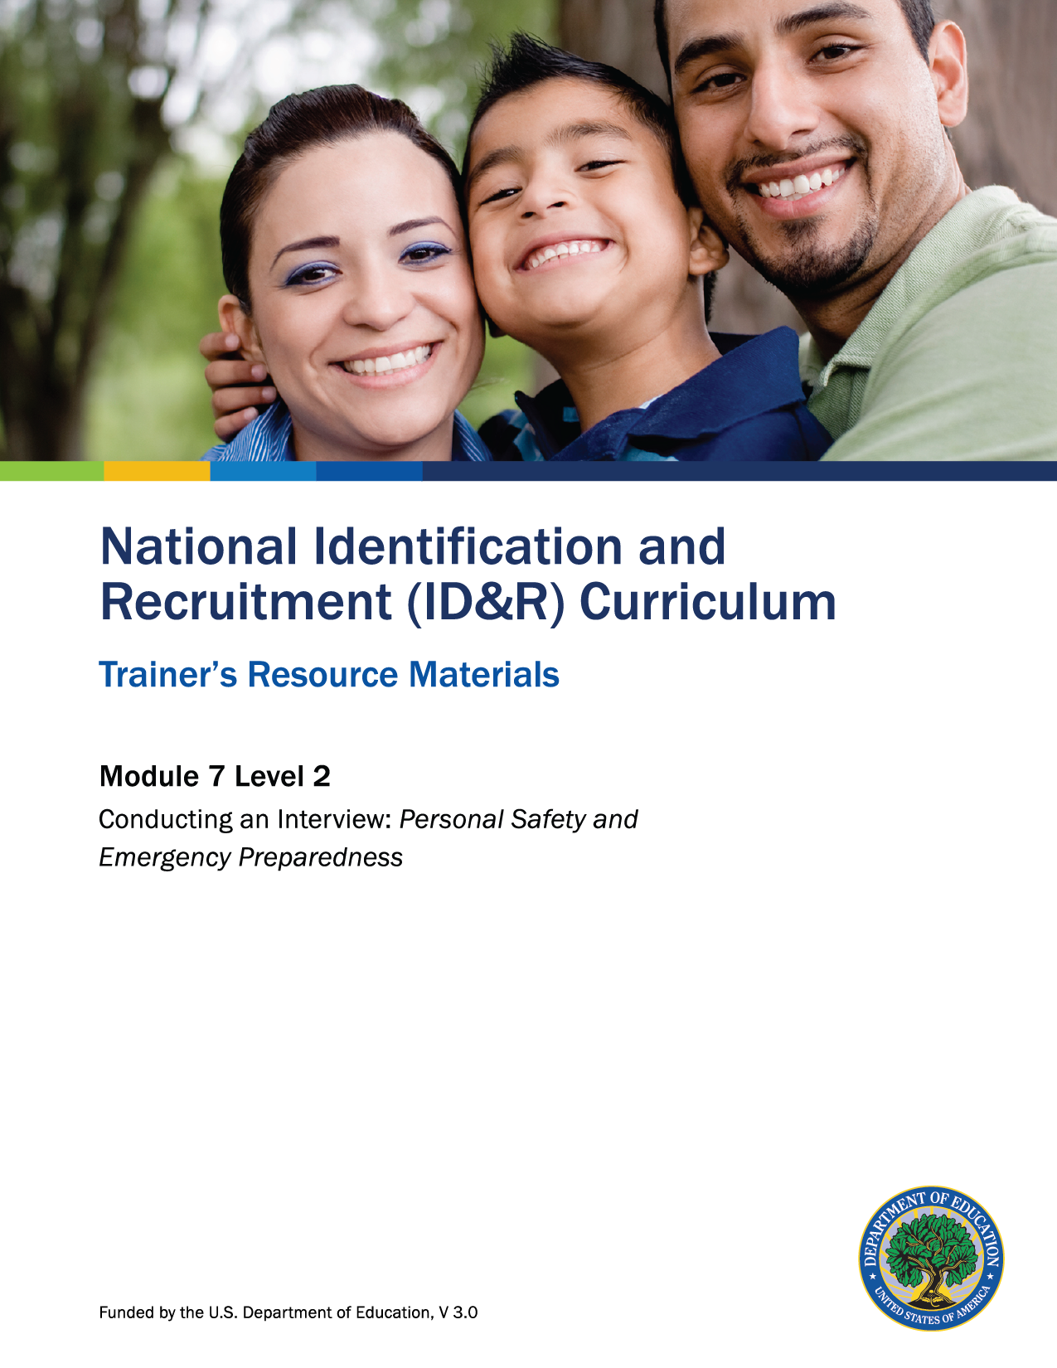

How to Use the Trainer’s Resource Materials
Name of Activity | Slide # | Title of Resource Page(s) | Page # | Prep Directions for  Resource Pages
Recognizing Emergency Situations | 11 | Recognizing Emergency Situations | 3 | One copy per participant
Troubleshooting Unsafe and Emergency Situations | 12 | Unsafe and Emergency Situation Cards | 4–6 | Duplicate cards onto cardstock. Cut cards apart to tape onto chart paper. Post chart paper around the room.
Recruiter Safety Review | 17 | Safety While Recruiting | 7–9 | One copy per participant
Level 2: Assessment | 18 | Level 2: Assessment and Key | 10–11 | One copy per participant; Key is for trainer only.

Recognizing Emergency Situations

From the list below, determine the risk of the potential emergency: none, low, moderate, or high.
Possible Hazards and Emergencies | Risk Level  (None, Low, Moderate, or High)
Floods
Hurricanes
Thunderstorms and lightning
Tornadoes
Winter storms and extreme cold
Extreme heat
Earthquakes
Volcanoes
Landslides and debris flow
Tsunamis
Fires
Wildfires
Hazardous materials incidents
Nuclear power plants
Explosions
Biological threats
Chemical threats
Nuclear blasts

Unsafe and Emergency Situation Cards

You are on a rural road, driving between appointments. The radio announces a tornado warning for the area you are driving into.

A sudden thunderstorm causes a flash flood warning while you are in the middle of interviewing a parent at her home on a farm.

What should you do?
Barking dogs surround your car as you drive up to a house for an appointment.

What should you do?

Unsafe and Emergency Situation Cards

Driving up to an apartment complex, you see a group of young men standing at the base of the stairs you need to access.

What should you do?
You are knocking on an apartment door, disturbing a bee hive that you did not see hanging above the door. The bees swarm around you.

What should you do?
While you are in the neighborhood of a migratory family, a nearby chemical plant experiences an explosion.

What should you do?

Unsafe and Emergency Situation Cards

You become lost in an unfamiliar area of town as you are looking for a migratory family.

What should you do?
While driving between appointments in a rural area, your vehicle begins to make strange noises and starts stalling when you press on the gas.

What should you do?

Safety While Recruiting
[Excerpt: National ID&R Manual, Chapter 5: Developing Action Plans and Contacting Families]
Dogs have chased me on recruitment visits, so now I always check to be sure that they are chained. If they aren’t chained, I stay in my car and call for someone to come out and get the dog before I get out of the car. I’m required to call my office twice a day so they know I’m safe.
The recruiter should always be alert to surroundings and be aware of his or her personal safety and security. Driving down a country road after dark, entering a building in a dangerous part of town, coming across threatening dogs guarding a farmhouse, or being female in a camp full of males are just a few situations the recruiter may encounter. Many of these circumstances arise in any outreach job, and some occur because of the rural nature of ID&R. Each MEP should have safety policies that are reviewed during the recruiter’s initial training. In addition, many MEPs find it useful to meet annually with local law enforcement officers to review personal safety strategies. Planning, preparation, awareness, and common sense can be the recruiter’s best defense. Experts on safety refer to an individual’s “instincts” or “sixth sense” that warns of danger. If a situation does not “feel” right, the recruiter should rethink the visit and return another time. Safety is always the first priority of the MEP. No student enrollment opportunity is greater than a recruiter’s personal safety. If the recruiter is in a dangerous situation, he or she should leave and return another time with additional support (recruitment team or agricultural employer). Using personal safety strategies such as those described below are important. States may come up with a range of safety measures. For example, some safety strategies may be best practices, others may be part of a safety system, and finally, many states enforce safety protocols.

Best practices for recruiters include the following:
- Only enter migratory housing if necessary; most recruitment paperwork can be completed outside regardless of the season.
- Conduct pair or team recruiting visits whenever possible.
- Female recruiters can have a male outgoing message on their voicemail, such as
“Hi, you’ve reached Jen and Jason, please leave a message,” in order to deter unwelcomed voicemail and text message advances.
- Always have car keys readily accessible.
- Always carry a cell phone; 911 still works without reception.
- Consider carrying mace or pepper spray.
- Pay attention to instincts; recruiters should react appropriately if feeling unsafe.
- Pay attention to personal behavior; sometimes a recruiter’s friendly behavior can
give the wrong impression, especially if cultural differences are present.
- Notify a farm employer or manager upon visiting farm worker housing.
- Consider taking a self-defense course.
Best practices for systems include the following:
- Pre-schedule farm visits whenever possible.
- Use a buddy information system with colleagues to keep everyone informed of when and where the recruiter is going to be while conducting recruitment efforts.
- Provide training on proper responses to uncomfortable advances.
- Provide training on how to report incidents and provide samples of previous reports to make new staff aware of potential situations.
Protocols include the following:
- Do not distribute personal phone numbers of colleagues (or others) without their permission.
- Dress code — recruiters should wear MEP t-shirts and/or MEP vests if possible.
- Maintain a schedule with information on when and where recruitment efforts will take place.
- Do not recruit after dark unless pre-scheduled and accompanied by a buddy. (University of Vermont Extension, Migrant Education Program, 2011)
This information should be used as a guide to help ID&R administrators and recruiters come up with their own safety measures. While serious safety situations are a rarity in the MEP, unfortunately they do occasionally occur. The best defense against danger is being informed, having a proactive safety plan, and knowing what to do if a problem does occur.
Communication. The recruiter should always carry a cell phone with emergency numbers in the speed dial and have a backup plan for rural areas that may not have cell phone reception (recruiters who do not have a cell phone may want to invest in a walkie-talkie or other communication device). Before going on the road, the recruiter should tell a responsible coworker the day’s visitation schedule and an expected time of arrival back at the office or home. When recruiting at a work site, the recruiter should check in with the farmer or crew leader before beginning recruitment activities. The authorities should be notified if the recruiter does not arrive at a particular destination on time and cannot be reached by telephone.

Local Knowledge. The recruiter should plan visits with safety in mind. Knowing which labor camps or neighborhoods may be cause for concern or what apartment complexes should not be visited alone may keep the recruiter from entering a potentially dangerous situation. The recruiter should consider which areas are best visited during daylight hours and whether a team, rather than an individual, should visit a particular apartment building. This type of information, which may be shared by local school personnel or community agency staff, should never be ignored. The recruiter should also be aware of the locations of local police stations, hospitals, and businesses that are open late. It is also important that the local community is aware of the MEP and the recruiter. Wearing a badge that has the recruiter’s name and place of employment can establish credibility and identity in case of an emergency. The recruiter should also be careful not to share too much personal information, particularly a home address or home telephone number.
Transportation. Recruiters should make sure that car doors are locked when not in the vehicle and keep valuables out of view. The recruiter’s car should be properly maintained and mechanically sound. Having a reliable car with a full tank of gas is a necessity when driving in rural areas. When possible, the recruiter should choose well-traveled roads and avoid shortcuts through isolated areas. The recruiter should have good maps (traditional or those downloaded from the Internet) to avoid getting lost. Many recruiters are issued GPS units or other navigation devices to aid in recruitment safety and efficiency. Emergency items (car jacks, flares, blankets, matches, flashlights, candles, water, a shovel in colder climates, etc.) can help the recruiter stay safe until help arrives in the case of an accident or an emergency.

Level 2: Assessment

What is the difference between an unsafe situation and an emergency situation?

List five best practices that would help maintain a recruiter’s safety in the field.

Level 2: Assessment Key

What is the difference between an unsafe situation and an emergency situation?
Accept all responses that include the following information:
- An unsafe situation is one that can cause harm, damage or loss.
- An emergency situation is an unexpected and usually dangerous situation that calls for immediate action.

List five best practices that would help maintain a recruiter’s safety in the field.
Accept any of the following responses.
- Only enter migratory housing if necessary. Most recruitment paperwork can be completed outside regardless of the season.
- Conduct pair or team recruiting visits whenever possible.
- Always have car keys readily available.
- Always carry a cell phone; 911 still works without reception.
- Consider carrying mace or pepper spray.
- Pay attention to instincts; recruiters should react appropriately if feeling unsafe.
- Pay attention to personal behavior; sometimes a recruiter’s friendly behavior can give the wrong impression, especially if cultural differences are present.
- Notify a farm employer or manager upon visiting farm worker housing.
- Pre-schedule farm visits whenever possible.
- Use a buddy information system with colleagues to keep everyone informed of when and where the recruiter is going to be while conducting recruitment efforts.
- Maintain a schedule with information on when and where recruitment efforts will be taking place.
- Do not recruit after dark unless pre-scheduled and accompanied by a buddy.
- Dress code – recruiters should wear MEP shirts and/or MEP vests if possible.

