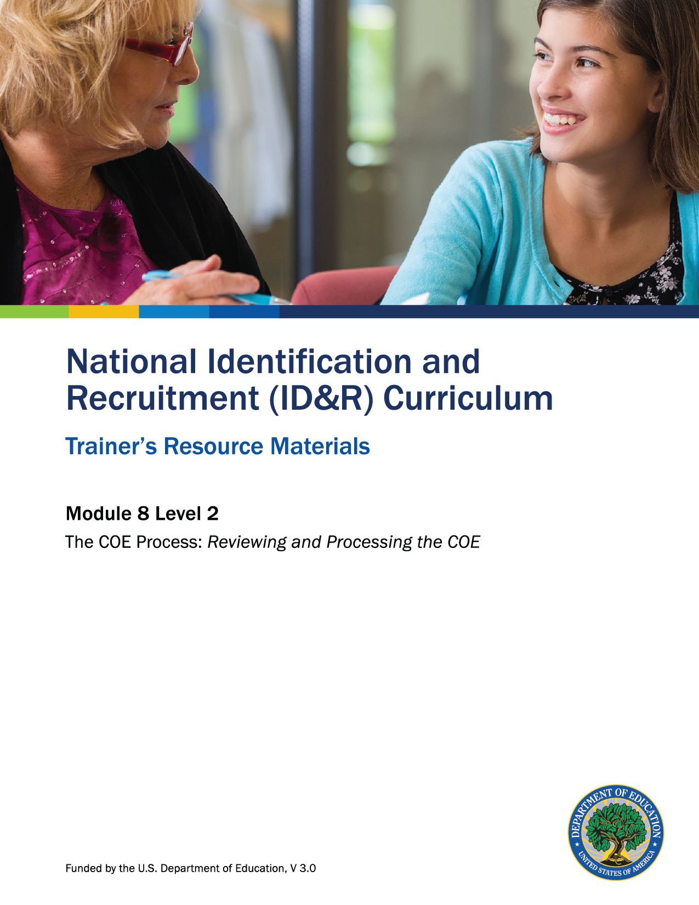

How to Use the Trainer’s Resource Materials
Name of Activity | Slide # | Title of Resource Page(s) | Page # | Prep Directions for  Resource Pages
Next Steps for the COE | 17 | Next Steps for the COE Flowchart – Key | 3 | Key is for trainer only
 | 25 | Next Steps for the COE Cards | 4
Level 2: Assessment | 26 | Level 2: Assessment and Key | 5–6 | One copy of the assessment per participant; Key is for trainer only.

Additional resources needed:
- Sample completed COE, one copy for trainer to display on document viewer. See Slide 7 for additional information.
Next Steps for the COE Flowchart – Key
COE is not signed because children do not qualify.

COE is sent back to recruiter for corrections/clarification.

COE has no errors and all eligibility factors have been met.
Reviewer signs COE.
COE is forwarded to state MEP for review (if applicable)

COE is approved by state MEP and returned to reviewer for signature.

Recruiter corrects COE and/or obtains more information from parent regarding eligibility factors.
COE is not approved by state.
Children qualify for MEP services and COE data is entered into state migratory student database.
COE has errors or eligibility factors are in question.
Recruiter forwards COE to SEA-designated reviewer for review and signature.

Completed COE is signed by parent and recruiter.

COE is reviewed by recruiter using all available resources.

Next Steps for the COE Cards

NOTE: Trainer should revise these cards if the Next Steps for the COE Flowchart was revised/customized for his State.
Completed COE is signed by parent and recruiter. | COE is reviewed by recruiter using all available resources. | Recruiter forwards COE to SEA designated reviewer for review and signature. | COE has errors or eligibility factors are in question. | COE is not signed because children do not qualify.
COE is forwarded to the State MEP for review (if applicable). | COE is sent back to recruiter for corrections/ clarification. | COE has no errors and all eligibility factors have been met. | COE is not approved by the State. | Children do NOT qualify for MEP.
Recruiter corrects COE and/or obtains more information from parent regarding the eligibility factors. | Reviewer signs COE. | Children qualify for MEP services and COE data is entered into the State migratory student database by data entry specialist.

Level 2: Assessment

List five resources a recruiter should have available to review a COE.

Which of the following people might review a COE? Check all that apply.
SEA Reviewer
Recruiter
Data Specialist
Parent
State MEP Staff

List one federal requirement for storing COEs and why it is important.

Level 2: Assessment Key

List five resources a recruiter should have available to review a COE.
Responses may include the following. Accept any reasonable response.
- State migratory student data base; MSIX
- School records
- Online mapping service
- Websites with crop information/agricultural maps
- State manual and MEP Non-Regulatory Guidance

Which of the following people might review a COE? Check all that apply.
SEA Reviewer
Recruiter
Data Specialist
Parent
State MEP Staff

List one federal requirement for storing COEs and why it is important.
Federal requirements may include one of the following:

- Ensure that records are stored in an orderly fashion and readily available if needed.
- Store COEs in a secure place.
- Follow local, state, and federal record-keeping and maintenance requirements.

Accept any reasonable justification for why it is important.

