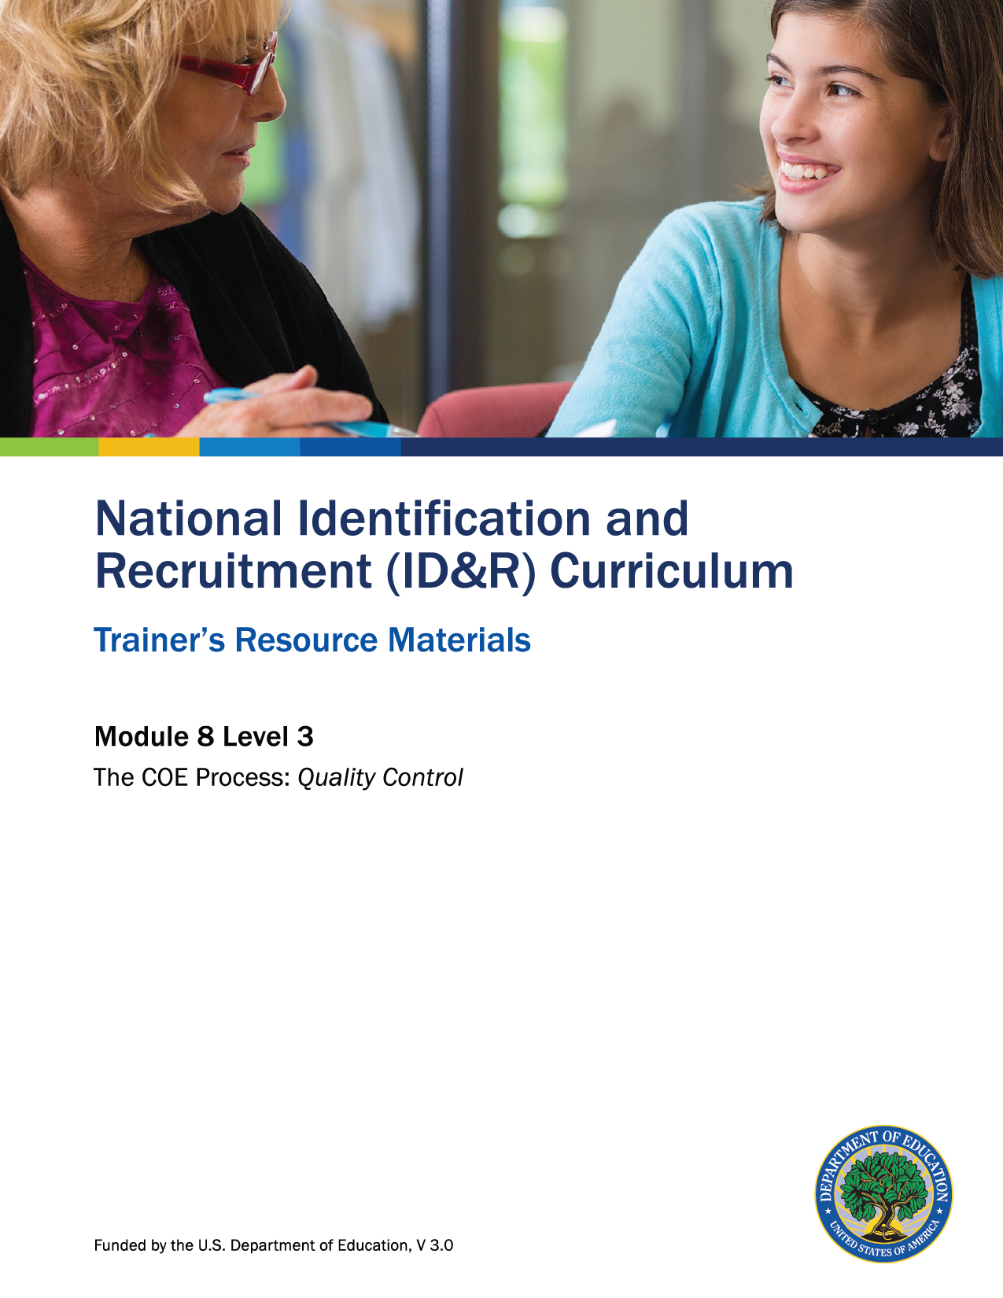

How to Use the Trainer’s Resource Materials
Name of Activity | Slide # | Title of Resource Page(s) | Page # | Prep Directions for  Resource Pages
Jigsaw: Quality Control in the ID&R System | 8 | Readings: Quality Control in the ID&R System | 3–6 | Number of copies needed will depend on the number of participants. Divide the number of participants by four to determine how many of each reading is needed.
 |  | Jigsaw: Quality Control in the ID&R System – Key | 7–8 | One copy per participant
Support for Recruiters | 13 | What Type of Recruiter Support Is Needed in My District? | 9-10 | One copy per participant
Benefits and Consequences | 25 | Benefits and Consequences Statements and Key | 11  12 | Copy statements on cardstock, cut apart and place in a bag or paper clip together. Disregard headings. Distribute one set per pair of participants.  For Key, make one copy per participant.
Level 3: Assessment | 30 | Level 3: Assessment and Key | 13–16 | One copy of the assessment per participant; Key is for trainer only.

Reading #1: Basic Principles
For the MEP, the primary focus of the quality control system is to determine whether only eligible migratory children are enrolled in the program. When the SEA qualifies an ineligible child or youth for the MEP, a defective eligibility determination has occurred. A strong ID&R quality control system will result in
- developing standard procedures that consistently result in correct MEP eligibility decisions;
- developing effective training programs to give recruitment staff the knowledge and skills needed to make correct MEP eligibility decisions;
- inspecting and testing MEP eligibility, particularly in areas where problems are most likely to occur;
- taking corrective action when problems are found to make sure they do not
happen again; and
- receiving fewer complaints and maintaining public confidence by making sure
that federal dollars are spent on eligible children.

The purposes of quality control are to (1) ensure that the SEA's system of identifying children eligible for MEP services is working properly, (2) find children who have been incorrectly determined to be eligible for the MEP, and (3) identify where problems have occurred and fix them. When an administrator finds an incorrect eligibility determination, the administrator should determine what part of the ID&R process failed and why. For example, the failure might have occurred because the recruiter did not ask enough questions during the interview, the interview was not translated properly, or the recruiter did not fully understand the eligibility criteria. Once the administrator knows what went wrong, he or she can use this information to improve the ID&R process by offering better training, meeting with recruiters more frequently, or providing clearer ID&R guidance.

Reading #2: Federal and State Requirements
A core responsibility of each SEA is to ensure that only those children and youth who are truly eligible for the MEP are recruited, counted and served. Each recruiter plays an important role in helping the SEA get the data it needs to make accurate MEP eligibility decisions and produce an accurate state child count. To that end, the State produces an annual Child Count Narrative that explains how the state counts only those children who met the program eligibility criteria and resided in the state for at least one day during the eligible period.
Furthermore, the State is required to describe how it ensures the quality of all child eligibility determinations. One way this is ensured is through the federally mandated re-interview process. Meeting this responsibility is key to ensuring that
- the State only provides MEP-funded services to eligible migratory children;
- the MEP allocation each state receives reflects its statutory share of the MEP funding that Congress appropriates annually for services to migratory children; and
- public confidence and the integrity of the MEP remains strong.
Rigorous quality control should be applied to all components of the ID&R process to ensure accountability and accuracy at every stage.
Everyone who works in ID&R, including the recruiter and the administrator, is responsible for knowing the child eligibility requirements and ensuring quality control. The recruiter’s role includes conducting comprehensive eligibility interviews, filling out the COE adequately and accurately, and helping to make correct eligibility determinations. The administrator has primary responsibility for ensuring that the quality control system works.

Reading #3: Quality Control of MEP Processes
For purposes of the MEP, there are two kinds of quality control activities: quality control of MEP processes and quality control of MEP products. This section focuses on the processes.
Quality control of MEP processes looks at each action a recruiter takes to determine whether a child is eligible for the MEP and attempts to pinpoint where errors are the most likely to occur.
To explain how quality control of processes works, consider an example from the car manufacturing industry. Car manufacturers have inspectors who check each job within the plant to see if that job was done correctly. If a worker forgets to screw in a bolt when installing a headlight, that worker has made an error in the manufacturing process, which may lead to a loose headlight.
To apply this same principle to ID&R, if a recruiter forgets, when conducting an interview, to ask if every child in the family moved, that recruiter has made an error in the MEP process. This may lead to mistakenly enrolling a child in the MEP who is not eligible. Following are some other examples of MEP process errors in determining child eligibility:
- Not asking enough questions.
- Misinterpreting or not understanding some aspect of the law, regulations, or NRG.
- Ignoring facts provided during an interview.
- Forgetting to ask the reason why a family moved.
To eliminate or reduce errors which can lead to defective eligibility determinations, administrators and recruiters must understand and accept that
- an error or mistake in the recruiting process can lead to an incorrect eligibility determination;
- the overwhelming majority of errors are human errors;
- to fix a problem, the source of the problem must be determined and the mistake learned from; and
- detecting and correcting human errors quickly is critical to reducing the number and cost of incorrect eligibility determinations.

Reading #4: Quality Control of MEP Products
For purposes of the MEP, there are two kinds of quality control activities: quality control of MEP processes and quality control of MEP products. This section focuses on the products.
Quality control of MEP products examines the outcome or product to identify defects and suggest improvements. Errors in MEP products would be identified after the COE has been completed, signed, and the eligibility determination has been made. In the world of the MEP, quality control of MEP products would occur through re-interviewing migratory families.
- One way that States and districts confirm the quality of eligibility determinations is by annually re-interviewing the families of currently eligible children. This process is referred to as prospective re-interviewing. Each SEA must have a process for re-interviewing a sample of migratory children each year. For a detailed explanation of how to conduct prospective re-interviewing, see section III of the OME Technical Assistance Guide on Re-interviewing. In general, OME recommends that each recruiter have at least one randomly selected eligibility determination checked each year. The re-interview should be conducted shortly after the initial interview as (1) the interviewee will be easier to locate, (2) it will be easier for the interviewee to remember what he or she said in the original interview, and (3) the program can catch and correct mistakes more readily.
The SEA must maintain documentation regarding (1) how the quality control process was implemented, (2) what the findings were, and (3) how they were resolved.

Jigsaw: Quality Control in the ID&R System – Key

Basic Principles
- A strong ID&R quality control system will result in several outcomes. Which outcome(s) is most needed in your area?
Responses will vary.

- Explain the purpose of quality control.
The purpose of quality control is to find children who have been incorrectly determined to be eligible for the MEP and to identify where problems have occurred and fix them.

- What should an administrator do if an incorrect eligibility determination is found?
The administrator should determine what part of the ID&R system failed and why.

Federal and State Requirements
- How does a recruiter help the state meet its core responsibility?
The recruiter helps the state get the data it needs to make accurate MEP eligibility decisions and produce an accurate state child count.

- What is one way the state ensures the quality of all child eligibility determinations?
Through the federally mandated re-interview process.

- Who is responsible for knowing the eligibility requirements and ensuring quality control?
Everyone who works in ID&R is responsible for knowing the eligibility requirements and ensuring quality control—the recruiter, administrator, reviewer, and data specialist.

Quality Control of MEP Processes
- What are examples of MEP process errors?
Examples may include
  - not asking enough questions;
  - misinterpreting or not understanding some aspect of the law, regulations, or NRG;
  - ignoring facts provided during an interview; and
  - forgetting to ask the reason why a family moved.
- What can happen when a recruiter makes an error in the MEP process?
A child who is not eligible may mistakenly be enrolled in the MEP.
- Recruiters and administrators must have some basic understanding regarding errors. Name two.
Responses may include two of the following:
- An error or mistake in the recruiting process can lead to an incorrect eligibility determination.
- The overwhelming majority of errors are human errors.
- To fix a problem, the source of the problem must be determined and the mistake learned from.
- Detecting and correcting human errors quickly is critical to reducing the number and costs of incorrect eligibility determinations.

Quality Control of MEP Products
- What is an example of an MEP product?
An MEP product would be the completed and signed COE.

- Why do states and districts re-interview the families of currently eligible children?
To confirm the quality of eligibility determinations.

- Why is it important to conduct a re-interview shortly after the initial interview?
Responses may include:
- The interviewee will be easier to locate.
- It will be easier for the interviewee to remember what he or she said in the original interview.
- The program can catch and correct mistakes more readily.

What Type of Recruiter Support Is Needed in my District?
Type of support | Currently in Place (√) | Would Like to See Happen (√) |  | Next Steps
Hiring qualified recruiters.
Providing orientation programs for new recruiters and ongoing training for all recruiters.
Testing the recruiter’s knowledge of eligibility rules.

Providing tools to help the recruiter make correct eligibility determinations.
Having the new recruiter observe knowledgeable and skillful recruiters conduct interviews with migratory families and youth and receiving guidance and feedback from them.
Having the supervisor observe the recruiter conduct an eligibility interview, particularly during the first months on the job.
Checking with the recruiter on a regular basis to make sure the recruiter is using a systematic, logical and efficient interview process.
Providing opportunities for the recruiter and other recruitment staff to talk about situations they have encountered and discuss whether particular children are eligible for the MEP.
Having the recruiter work with others to make final eligibility determinations, particularly in difficult cases.
Developing a recruiter ethics policy.

Providing incentives for reducing errors.

Benefits and Consequences Workmat
Consequences of an  Ineffective Quality Control System | Benefits of an  Effective Quality Control System

Benefits and Consequences Statements and Key
Consequences of an  Ineffective Quality Control System | Benefits of an  Effective Quality Control System
Returning MEP funds that were allocated based on erroneous data. | Protecting the integrity of the MEP.
Incurring the costs of corrective actions required because of program monitoring or audit. | Ensuring only eligible migratory children benefit from MEP services.
Losing the trust of state and local administrators, OME representatives, other partners, and the general public. | Ensuring that each state only receives funding for students who are eligible.
Experiencing the personal anxieties and troubles associated with audits and their aftermath.

Level 3: Assessment

What is quality control in the MEP?

Four components of quality control in the MEP are listed below. Choose one of the components and explain the role it plays in quality control.
Components of quality control include the following:
- Support for recruiters
- Reviewing COEs
- Re-interviewing families
- Recordkeeping
The component I choose is ________________________________________
The role it plays in quality control is
_________________________________________________________________________________________
_________________________________________________________________________________________
_________________________________________________________________________________________

Place a check by those statements which are benefits of an efficient ID&R quality control system.
Incurring the costs of corrective actions required because of program monitoring or audit.
Ensuring that each state only receives funding for students who are eligible.
Protecting the integrity of the MEP.
Returning MEP funds that were allocated based on erroneous data.
Losing the trust of state and local administrators, OME representatives, other partners,
and the general public.
_ Ensuring that each state only receives funding for students who are eligible.

Level 3: Assessment Key

What is quality control in the MEP?
Responses may include part or all of the following. Any reasonable answer may be accepted.
Quality control in the MEP ensures
- that the state only provides MEP-funded services to eligible migratory children;
- the MEP allocation each state receives is based solely on eligible migratory children; and
- public confidence and the integrity of the MEP remains strong.

Four components of quality control in the MEP are listed below. Choose one of the components and explain how it can impact quality control.
Components of quality control include the following:
- Support for recruiters
- Reviewing COEs
- Re-interviewing families
- Recordkeeping
Responses may include the following:
- The component I choose is support for recruiters.
- It impacts quality control in the following way(s):
  - When a district provides support for recruiters (training, mentors, feedback, etc.), the error rate on COEs will decrease.
  - The component I choose is reviewing COEs.
- It impacts quality control in the following way(s):
  - Local MEPs can create a review process for COEs before they are entered into the state migratory student database system that includes the recruiter, reviewer, and database system specialist. An MEP can also create a procedure for review of all COEs that will catch any errors that may have slipped by the recruiter and reviewer.
  - The component I choose is re-interviewing families.
- It impacts quality control in the following way(s):
  - Re-interviewing families is a process conducted by the state MEP. It allows the state to validate that eligibility determinations were properly made.
  - The component I choose is recordkeeping.
- It impacts quality control in the following way(s):
  - Because it is a federally funded program, local MEPs are required to keep all eligibility documentation on file and readily available. Having accurate documentation helps ensure identified students meet all the required eligibility factors.

Place a check by those statements which are benefits of an efficient ID&R quality control system.
Incurring the costs of corrective actions required because of program monitoring or audit.
Ensuring that each state only receives funding for students who are eligible.
Protecting the integrity of the MEP.
Returning MEP funds that were allocated based on erroneous data.
Losing the trust of state and local administrators, OME representatives, other partners and the general public.
Ensuring that each state only receives funding for students who are eligible.

