Appendix XV: State ID&R Models

Introduction
SEAs are often interested in finding the best way to organize resources of the MEP to conduct ID&R in an efficient and effective manner. While numerous ways of structuring an ID&R system exist, six common approaches can be distinctly identified. The models range from using only an SEA-level recruiter(s) to serve a geographically small state with a numerically small migratory population to a model that requires state and regional level staff, a resource center, and many recruiters employed at many LOAs to serve a very large migratory population that is scattered throughout a large state.
Each of the six basic models of organizing for ID&R has advantages and disadvantages. Which model a state selects to operate depends greatly on a number of factors that are specific to each state (e.g., the size, mobility, residential density of the migratory population, the type and schedule of qualifying agricultural or fishing activities that migratory workers seek and in which they engage, the type of housing available to migratory families, the level of MEP funding, the type of MEP projects offered).

The Models
The six models discussed in the pages that follow are
- Model A: State Recruiter Model
- Model B: Local Recruiter Model
- Model C: ID&R Coordinator and Local Recruiters Model
- Model D: ID&R Coordinator, State Recruiters, and Local Recruiters Model
- Model E (1): Regional Office Model
- Model E (2): Regional Office and ID&R Center Model
A brief description of each model follows with its advantages and disadvantages. It is hoped that this summary of the six basic models will provide ideas on the best way to organize and/or improve an ID&R system in a particular state.

Model A: State Recruiter
The SEA employs one or more “state recruiter(s)” who conduct all recruitment activities statewide. The state recruiter function is highly centralized and could be performed at the SEA, at an LOA, or through a contract. Typically, states that are small in size and have a small migratory population use model A.
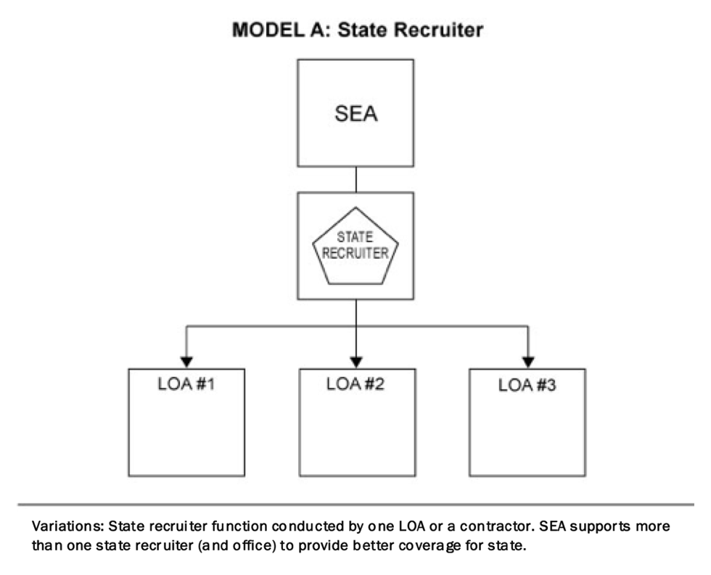
Key Players:
- MEP Director/Representative
  - serves as a liaison between state and federal government
  - sets state and local MEP rules
  - ensures that federal guidelines are adhered to
  - administers quality control systems
- State Recruiter
  - state employee(s) or contractor(s) who specialize(s) in identifying and recruiting eligible migratory children
- Local Operating Agency
  - receives funds to provide services or make referrals
  - does not do actual recruitment, though may notify recruiter if migratory families are found
Model A Advantages:
- Centralized authority. The state makes all policy and procedural decisions, which increases speed and consistency.
- Specialization. One or more staff specializes in ID&R which may result in better-prepared and more knowledgeable recruiters since they can focus exclusively on ID&R (versus part-time recruiters who have many other responsibilities).
- Consistency. Having a single person/entity make all eligibility determinations increases the likelihood of consistent practices throughout the state.
- Less incentive for fraud/abuse. Statewide recruiters generally have less incentive than local recruiters to make questionable eligibility determinations to increase the numbers so as to prevent a particular LOA from being adversely impacted by low or fluctuating numbers.
- Coverage of non-project areas. Statewide recruiters typically cover non-project areas, unlike local recruiters who generally remain within project boundaries.
Model A Challenges:
- Recruiter viewed as an “outsider.” State recruiters are generally outsiders in communities in which they recruit and therefore may have to work harder to determine where migratory families are likely to reside and to establish the trust and cooperation of migratory families, local growers, other employers, the school, etc.
- Dependence on skill of state recruiter. The quality of the recruitment system is dependent on the skill and work ethic of one state recruiter or a small number of state recruiters.
- Travel time and isolation. State recruiters are likely to spend a lot of time traveling and feeling isolated and lonely.
- Coverage. State recruiters may have a hard time covering all parts of the state during peak enrollment periods when migratory families are arriving in a number of districts simultaneously.
- Connection with families. The connection with individual migratory families might not be as strong when one person does the recruitment and others provide services as when the recruiter also provides services (e.g., serves as a liaison with the school; does parent involvement, advocacy, or case-management).
- Succession planning. Since the state recruiter is generally the most knowledgeable person in the state regarding the intricacies of student eligibility, when that position is vacated (e.g., the state recruiter gets sick or takes a new position), it can take a new staff member a long time to master the body of knowledge required by the position.
  - Local ownership. Local projects may not have the same degree of ownership and interest in the migratory program when a state recruiter does the recruiting.
  - No second checks on COEs. If a single person does all of the recruiting statewide, there isn’t anyone with a comparable level of expertise to do a second review of COEs.
  - Delegation. The SEA may have a tendency not to pay as much attention to ID&R when they have a statewide recruiter, even though the state is ultimately responsible for the quality/accuracy of child eligibility determinations.
  - Uneven distribution of responsibilities. The state recruiter may have too many responsibilities and the SEA may have too few. This is also related to delegation, planning as well as implementation, coverage, travel time, and isolation.

Model B: Local Recruiter
Each LOA employs its own local recruiter with oversight by the SEA (generally through monitoring). The recruitment function is highly decentralized, with direct supervision, training, support, etc., occurring at each LOA. Typically, states that have districts that are geographically spread out and with limited numbers of migratory children use this model. States that use model B are often slightly larger than states that adopt model A.
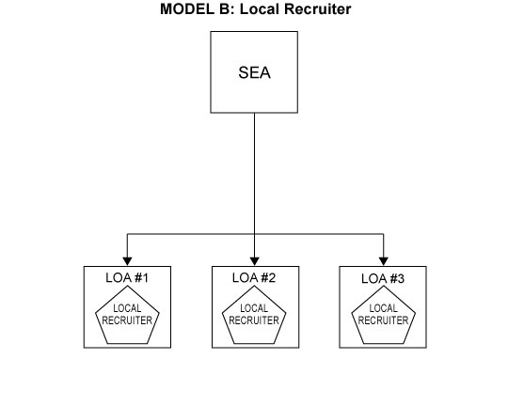
Key Players:
- MEP Director/Representative
  - serves as liaison between state and federal government
  - sets state and local MEP rules
  - ensures that federal guidelines are adhered to
  - administers quality control systems, including verification of COEs
- Local Recruiter within LOA
  - lives in community
  - knows community
  - is not an outsider
- Local Operating Agency
  - employs and supports local recruiter

Model B Advantages:
- Stronger connection with families. Recruiters are more likely to have stronger connections with individual migratory families and to function effectively as a liaison, advocate, and/or case-manager within the school.
- Recruiters are “insiders.” Local recruiters are generally hired from within the community in which they recruit, so they may have an easier time gaining the trust and cooperation of migratory families, local growers, other employers, the school, etc. They also have more opportunities to establish recruitment networks.
- Less dependent on an individual recruiter. Since the program employs a number of recruiters, it is less dependent on the skill and work ethic of any one recruiter. Also, recruiters can share ideas and collectively develop more efficient and effective recruiting techniques.
- Travel time and connection. Local recruiters don’t need to spend as much of their time traveling, and they are more likely to feel connected to the local school and community.
- Coverage. Since local recruiters have a smaller area in which to recruit, they may have an easier time covering their assigned area during peak enrollment periods when migratory families begin to arrive in large numbers.
- Succession planning. Succession planning is easier since there are generally a number of experienced recruiters at any point in time that can help train/mentor new recruiters.
- Local ownership. Performing recruitment at the local level may lead to a greater sense of local ownership of the MEP program.
  - Flexible staffing. Temporary recruiters can be hired for peak enrollment periods rather than a full complement of recruiters year round.
  - Bundle job responsibilities. Recruiters can also be employed on a full-time basis and can handle other program responsibilities like serving as a family liaison, facilitating parent involvement, etc.
  - One specialist for each LOA. The local recruiter and/or specialist will have the opportunity to build stronger relationships with families and stakeholders.
  - More autonomy. The local recruiter or MEP specialist has specific training and/or experience in ID&R and is able to conduct assignments with greater independence.
  - More resources for project activities. Human and other resources, particularly time and travel funds, are concentrated on a specific area. Excess can be allocated for other academic and supporting activities.
  - Delegated/shared responsibilities. The local recruiter and stakeholders have greater involvement, thus increased decision making and more responsibilities.
Model B Challenges:
- Decentralized authority/consistency. Decision-making is more decentralized which makes it harder to achieve consistency across the state.
- Less specialization. Since recruiters are more likely to have a number of different job duties, they often have less time to spend learning all of the intricacies of child eligibility and therefore may be less knowledgeable.
- More incentive for fraud/abuse. Local recruiters may have more temptation to make questionable eligibility determinations to ensure that the number of identified migratory children increases or remains constant so their project doesn’t lose money.
- Coverage of non-project areas. The state may not have a mechanism in place to cover non-project areas (local recruiters generally recruit only within project boundaries).
- Coverage outside of the school. School-based recruiters tend to work solely in the school and not out in the communities where many additional migratory children are found. They may have a tendency to recruit less at work sites and in the community at large, which will result in a lack of preschool and OSY recruitment.
- Different pay scales. Districts are likely to have different pay rates, so recruiters who are performing essentially the same functions may be paid different rates depending on the district in which they work.
- Competing demands. State Directors in most states spend only part of their time working on the MEP and therefore may not have time to play an active leadership role or to have the resources to employ a state recruiter.
- The possibility of too much local autonomy. The local recruiters may have too many responsibilities and the SEA may have too few. This is also related to delegation,
planning as well as implementation, coverage, travel time, and isolation.
- Local recruiters may have too many responsibilities. Schools may expect local recruiters to input migratory student data into the system, assist with parental involvement activities, and track student progress in classes. These additional responsibilities leave very little time for ID&R.

Model C: ID&R Coordinator & Local Recruiters
The SEA employs a state ID&R Coordinator who provides training, technical assistance, quality control, and related functions for local recruiters that are employed by LOAs from across the state. While the recruitment function is decentralized, the state ID&R Coordinator’s role is to increase the level of standardization and consistency across the state. Typically, mid-size states use this model.

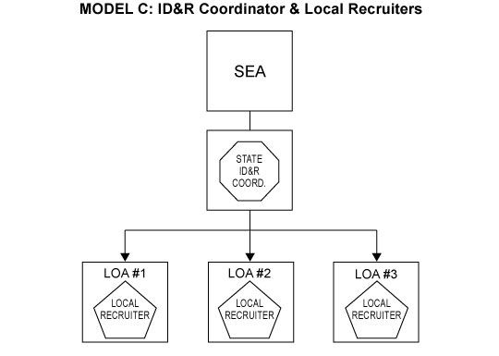

Key Players:
- MEP Director/Representative
  - serves as liaison between state and federal government
  - sets state and local MEP rules
  - ensures that federal guidelines are adhered to
- State Coordinator for ID&R
  - communicates state ID&R policy and standard operating procedures
  - conducts training
  - administers quality control systems
  - monitors work of local recruiters
  - may recruit in non-project areas
- Local Recruiter within LOA
  - lives in community
  - knows community
  - is not an outsider
- Local Operating Agency
  - employs and supports local recruiter
Model C Advantages:
- Consistency/standardization. This model allows for the advantages of a decentralized system, particularly local ownership and closer relationships with individual families, while providing increased consistency and standardization.
- Many of the same advantages of Models A and B.
- Increased state and peer support. These networks can be part of the team building process mentioned above. Communications can occur in person, via telephone, or email on a quarterly basis.
- Consistent or standardized training. State ID&R Coordinators are the primary providers of the state’s recruitment staff. Centralized training, quality control efforts, and technical assistance leads to more consistent recruitment efforts across the state.
Model C Challenges:
- Cost. This model is more expensive to operate than the previous models due to the added cost of the state ID&R Coordinator position.
- Travel. If the state ID&R Coordinator is located in the state (versus an LOA or as a contractor), the Coordinator may have a difficult time getting state approval to travel or getting approval may be a lengthy process.

Model D: ID&R Coordinator, State Recruiters, and Local Recruiters
Like Model C, the SEA employs a state ID&R Coordinator who provides training, technical assistance, quality control, and related functions for local recruiters that are employed by LOAs from across the state. The recruitment function continues to be decentralized, and the role of the state ID&R Coordinator is to increase the level of standardization and consistency across the state. This model has the added benefit of utilizing a state recruiter to cover non-project areas (the state recruiter could be a contractor or employed by a local LOA). Typically, this type of model would be adopted by a mid-size state.

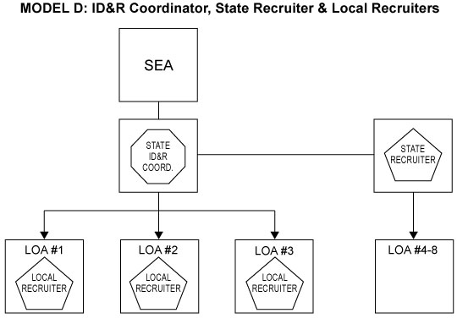

Key Players:
- MEP Director/Representative
  - serves as liaison between state and federal government
  - sets state and local MEP rules
  - ensures that federal guidelines are adhered to
- State ID&R Coordinator
  - communicates state ID&R policy and standard operating procedures
  - conducts training
  - administers quality control systems
  - monitors work of local and state recruiters
  - may recruit in non-project areas
- State Recruiters
  - state employee(s) or contractor(s) who specialize(s) in identifying and recruiting eligible migratory children outside of the LOA
- Local Recruiters
  - live in community
  - know community
  - are not outsiders
- Local Operating Agency
  - employs and supports local recruiter
Model D Advantages:
- Coverage. The state has greater coverage of non-project areas (i.e., outlying areas where migratory children exist, but that are not current project sites). Also, the state recruiter can “fill in” if a LOA loses a recruiter.
- Many of the same advantages of Models A and B.
Model D Challenges:
- Cost. This model is more expensive to operate than the previous models due to the
added cost of the state recruiter.

Model E (1): Regional Office
This is a hierarchical, pyramidal model that has a number of organizational levels. Typically, the state ID&R Coordinator supports a group of regional MEP directors, who supervise regional recruiters and/or provide guidance to local recruiters employed by LOAs. The state generally continues to make major policy and procedural decisions, which filter down through the hierarchy. Regional MEP directors and/or local administrators, however, make many of the operational decisions. Generally, this type of model would be adopted by a very large state.
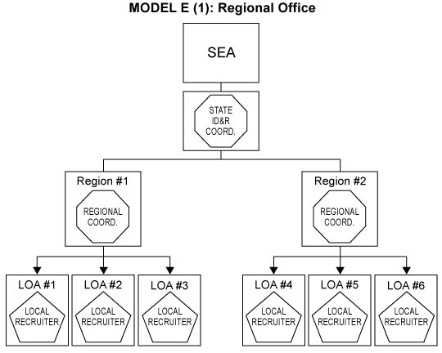

Key Players:
- MEP Director/Representative
- State ID&R Coordinator
- Regional MEP Director
  - directs operations of regional office (may include either instructional or
support services, or both)
  - supports MEP activities at the LOA level
- Local Recruiter
- Local Operating Agency

Model E (1) Advantages:
- Practical for very large states. Very large states may need to have a complicated organizational structure like this one because of the large number of recruiters needed to identify migratory families across the state. This avoids overburdening a single decision point, which can create “bottlenecks.”
- Delegation of authority. Regional MEP Directors have operating responsibility, which (1) frees the state to spend time on strategic decision-making, and (2) promotes flexibility and responsiveness at lower levels in the hierarchy.
- Task specialization. Makes more efficient use of employee skills and increases their skill level through repetition.
- Increased support for recruiters. There is more technical assistance and support available to ID&R staff at the local levels. Each LOA has access to a regional MEP Director (or staff person) that has had training and who has access to a state level counterpart for technical and other assistance.
- Stronger knowledge base of federal and state policy. Four of the possible five key players have strong connections to the state MEP: its roles, responsibilities, and resources, including the liaison with the federal program. The knowledge base is gained or strengthened through state-sponsored training and a communications network.
- Increased statewide coverage. There is also good coverage for outlying areas where migratory children exist but do not receive services as well as the capability of repositioning staff in the event of regular or unexpected population shifts.
- Additional support. Staff can work in teams.
Model E (1) Challenges:
- Cost. This model is expensive because of the number of administrative layers and can be top heavy administratively.
- Consistency. There are increased opportunities for variance in policy interpretation and procedures that could impact the implementation of the program.
- Lack of program cohesiveness. Regions may become increasingly remote from one another and from the state over time, or alternately, they could become competitive, particularly for funding.
- Greater need for networking and professional development with peers. Workload, distance from site to site, and priorities may necessitate individual efforts and even promote adverse competition. A decrease in networking may also weaken the integrity of the state’s MEP policy and practices.

Model E (2): Regional Offices & ID&R Center
The model is characterized by having local recruiters receive supervision/instruction from two sources, the LOA and the SEA (typically through a state ID&R Coordinator or ID&R center).
Generally, this type of model would be adopted by a very large state that has a large number
of migratory children and MEP staff.
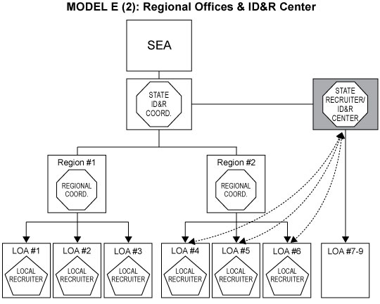

Key Players:
- MEP Director
- State ID&R Coordinator
- ID&R Center Staff
- State Recruiter(s)
- Regional MEP Directors
- Local Recruiter(s)
- Local Operating Agency
Model E (2) Advantages:
- Training. Many opportunities for cross-training/cross-learning.
- Multiple Staff. This system is constructed to meet the needs of the entire child.
Model E (2) Challenges:
- Organizational tension related to multiply supervised employees. There may be tension between state ID&R staff and regional staff. Recruiters have a direct reporting relationship to the LOA and/or region, yet they receive training and direction on how to perform their jobs from the state ID&R Coordinator/center.
- Cost. This model is also expensive because of the number of administrative layers.
- Statewide network. Though there are resources to meeting the academic and supporting needs of the migratory child, the assignment of roles and responsibilities may not be established.

