Chapter 1. Background and Overview of the Migrant Education Program

Chapter 1 Learning Objectives
The recruiter will learn
- the common characteristics of migratory agricultural workers and migratory fishers;
- the purpose of the MEP;
who is eligible to be recruited into the MEP;
- the importance of finding migratory children;
- how the MEP is organized; and
- how important the recruiter is to the ID&R process.

Children of Migratory Farmworkers and Fishers
Pedro is in his second school this academic year; his family moved from Texas to Michigan to harvest cherries.
Nancy was a freshman in high school last year, but now she has left school to pick apples with her father.
Thelma dreams of being a nurse someday, but knows she’ll never have enough credits to graduate from high school because her family keeps moving back and forth from California to Oregon.
These are the children of America’s migratory workers, and their education suffers as a consequence of their family’s mobile way of life. The purpose of the MEP is to locate these children, determine whether they are eligible for the program, and, if so, provide them with the supplemental instructional and support services they need to succeed in school.
Our nation’s economy depends upon workers who perform a variety of temporary and seasonal jobs that help produce, harvest, and process crops, livestock, poultry, fish, shellfish, dairy, and other agricultural products. The workers who fill these jobs are often forced to piece together a number of agricultural or fishing jobs to make a living that will sustain them and their families throughout the year. These jobs are often located far from one another, requiring the worker to move and reside temporarily in an area near the work. Due to economic necessity, many workers and their families migrate back and forth from a home base to locations where they can obtain one or more of these temporary or seasonal jobs. The workers who move in search of such work are known as “migratory” agricultural workers or fishers.
Migratory agricultural workers and fishers share a number of common characteristics that pose significant challenges in their lives:
- They repeatedly relocate for work due to economic necessity.
- They are often isolated from services.
- They are “working poor” as a result of the low wages they are paid for their labor.
- They often reside in sub-standard living conditions.
- They frequently have low levels of education.
- They are subject to inadequate or non-existent health care.
- They often feel isolated from the larger community because they come from a different culture and frequently speak a language other than English (some speak indigenous languages, making it difficult to find interpreters and translated materials).
- They often move to and from other countries (especially Mexico).
- Many live in fear due to documentation and legal status issues.
- These characteristics and life experiences create unique educational circumstances for the children of migratory workers and young migratory workers who move regularly.
- Migration means changing schools, teachers, and curricula, and often chronic absenteeism for school-age children. Changing schools diminishes a student’s sense of belonging and makes it more difficult to participate in the classroom and extracurricular activities.
- Children of migratory workers often have limited opportunities to learn the English language because their parents may not be proficient in English. Furthermore, children who spend part of the year in countries (and schools) in which English is not commonly spoken do not have as much opportunity to learn and practice English.
- Migratory parents’ low levels of education and socioeconomic status often limit the amount and quality of educational support that can be offered in the home.
- Health insurance and wages that ensure adequate access to health care for young children and adolescents are not generally provided by temporary and seasonal jobs in agriculture and fishing.
- Because they are temporary residents, migratory workers and their children are often treated like outsiders and may face discrimination. This fact may limit their access to services to which they are entitled.
- Students may not receive academic credit for courses they have completed when states do not have an active system for granting and transferring course credits earned within the state, or accepting course credits earned in other states.
Migratory children are known to be at high risk of school failure due to these characteristics and experiences. The unique educational needs that arise from the migratory lifestyle and the challenges our nation’s schools face in effectively educating a highly mobile and disadvantaged population keep that risk high.
Migratory out-of-school youth (OSY) who work in agriculture or fishing rather than attending school are at an even greater risk of failing to obtain the level of education required to succeed in life. These OSY may travel with families, an older relative or crew chief, in small groups, or alone. In the Consolidated State Performance Reports (CSPR) for 2014-2015, States identified 35,165 OSY eligible for services, which was 10.5 percent of the total population of migrant students identified as eligible for services (332,335) (ED, ED Data Express, 2014-2015). OSY face all of the obstacles to education encountered by other migratory students, plus additional challenges. OSY are seldom connected with the community in which they live, and as a result, the MEP may be their only link to education, support, and the medical services they need.

Purpose of the Migrant Education Program
In 1966, the U.S. Congress amended Title I of the ESEA to include a new section: Part C—Education of Migratory Children. Through this amendment Congress authorized, for the first time, a program that provided states with federal financial assistance to help improve the educational opportunities and academic success for the children of migratory agricultural workers. This program was called the Migrant Education Program, or MEP.
The ESEA, as amended by the ESSA, states that the purpose of the MEP is
- to assist states in supporting high-quality and comprehensive educational programs and services during the school year and, as applicable, during summer or intersession periods, that address the unique educational needs of migratory children;
- to ensure that migratory children who move among the states are not penalized in any manner by disparities among the states in curriculum, graduation requirements, challenging state academic standards;
- to ensure that migratory children receive full and appropriate opportunities to meet the same challenging state academic standards that all children are expected to meet;
- to help migratory children overcome educational disruption, cultural and language barriers, social isolation, various health-related problems, and other factors that inhibit the ability of such children to succeed in school;
- to help migratory children benefit from state and local systemic reforms. (Section 1301 of the ESEA, as amended)
The principal operational goal of the MEP is to ensure that all migratory students meet challenging academic standards so that they graduate with a high school diploma or receive a High School Equivalency Diploma (HSED) that prepares them for responsible citizenship, further learning, and productive employment.

Who is Eligible for the MEP?
The MEP was designed to help migratory children find success through education. Preparing a preschooler for kindergarten, helping a student learn to read or enhancing their English language proficiency, ensuring a child’s promotion to the next grade, and helping a high school student earn credits toward graduation are just a few examples of activities that the MEP supports. However, before the MEP can provide any services, MEP staff must determine that a child is eligible for the MEP. To understand migratory child eligibility, it is important to review the law.
According to sections 1115(c)(1)(A) (incorporated into the MEP by sections 1304(c)(2), 1115(b)), and 1309(3) of the ESEA, and 34 C.F.R. § 200.103(a)), a child is a “migratory child” if the following conditions are met:
- The child is not older than 21 years of age; and
  - the child is entitled to a free public education (through grade 12) under state law, or
  - the child is not yet at a grade level at which the LEA provides a free public education; and
- The child made a qualifying move in the preceding 36 months as a migratory agricultural worker or a migratory fisher, or did so with, or to join a parent/guardian or spouse who is a migratory agricultural worker or a migratory fisher; and
- With regard to the qualifying move identified in paragraph 3, above, the child moved due to economic necessity from one residence to another residence, and
  - From one school district to another; or
  - In a state that is comprised of a single school district, has moved from one administrative area to another with such district; or
  - Resides in a school district of more than 15,000 square miles and migrates a distance of 20 miles or more to a temporary residence. (NRG, Ch. II, A1)
Note for the three terms defined in both the statue and program regulations (“migratory child,” “migratory agricultural worker,” and “migratory fisher”), the statutory definition in the ESEA, as amended by the ESSA, takes precedence. In addition, the term “in order to obtain” no longer appears in statute, and its definition in 34 CFR § 200.81(d) is therefore no longer applicable.
Children who fit the above definition are eligible for MEP services. However, only those children who are between the ages of three and 22 (i.e., have not had a 22nd birthday) are counted for state funding purposes.

The Importance of ID&R in Determining Eligibility for the MEP
Working for the MEP means you are affecting the lives of the nation’s most disadvantaged children. Without the MEP, no one would be looking out for these children.
Identification means actively looking for and finding migratory children and youth. Recruitment means making contact with the family or youth and obtaining the necessary information to document the student’s eligibility and enroll them into the MEP.
The ID&R of migratory children is essential because the SEA must create a record of eligibility for each migratory child before he or she can receive any of the MEP’s educational or supportive services. The longer it takes a state to find a migratory child, the more time passes before the child receives the extra services he or she needs to succeed. Furthermore, the children who are most in need of MEP services are often the most difficult to find. Migratory children who are not identified may experience problems such as delays in placement or incorrect school assignment; failure to count partial credits or inappropriate course sequence for graduation from the student’s home-based school; and obstacles to receiving necessary supplemental services. Even if an individual migratory child does not receive direct services, it is important to identify all migratory children so their needs can be assessed and monitored to plan future services if a need does arise.
Effective ID&R is a challenge for the MEP. The proper and timely ID&R of migratory children may be a difficult task for a number of reasons:
- Not all temporary or seasonal workers are eligible for the MEP because the worker must have moved due to economic necessity from one residence to another and from one school district to another and have (1) engaged in new qualifying work soon after the move, or (2) if the worker did not engage in new qualifying work soon after the move, actively sought such employment and had a history of moves for qualifying work. The eligibility requirements for the MEP require strong analytical skills to properly evaluate eligibility.
- Migratory families are inclined to be self-sufficient and are not accustomed to seeking help outside of their own circle of family and friends.
- Children of migratory workers are often invisible, quietly coming and going, and not attracting much attention in a new community. If these children are not actively recruited, many would not be in school (they may accompany their parents to work or be left alone at home) or receive services from the MEP.
- Finding and recruiting many OSY who travel without their families or in groups of OSY is especially challenging. The traditional in-school recruitment model is not feasible because this population has no contact with the school district. Recruitment of OSY is most successful when it occurs at work sites, in the field, and at businesses where these youth work, as well as in housing where they live.
- Migratory families often do not speak or read English or are English language learners (ELLs), and some are not literate in their native language.
- Frequently, there are significant cultural barriers and misunderstandings between the migratory family and the community in which they reside.
- The places where migratory families work and reside are often located in remote areas, and employers may be uncomfortable if their employees have outside visitors during the workday. Employers may also discourage outside visitors because of concerns about liability, productivity, or the legality of their workers.
- There is considerable turnover in migratory agricultural and fishing work. The work is often difficult, dangerous, and, under the best circumstances, results in only modest wages. Living conditions in farmworker camps and other temporary, poorly maintained housing can be hard on all of the family members. Yet, while many migratory workers move into easier and more stable employment, others remain in or re-enter the migratory labor pool because they view the temporary or seasonal work in agriculture or fishing as their only employment option in the workforce.
- The MEP may not be able to serve all migratory children; the children may not currently need supplemental academic help or they may not be deemed a priority for service. Therefore, some families may not see an immediate benefit to their child being identified and may forgo the process.
For these and other reasons, the MEP needs to employ trained staff to identify and recruit migratory children. These staff members are usually called “recruiters,” and they receive extensive training in a basic set of procedures on how to find and recruit migratory children for the MEP.

Organization of the MEP
There are many state MEP organizational structures. An example of an MEP structure is found below in Figure 1. While the MEP is administered by a single office (OME) within ED, organizational structures below the federal level differ from state to state. Throughout the country, staff works on the MEP at the local, state, and federal levels.
Figure 1. A Typical MEP Organizational Structure
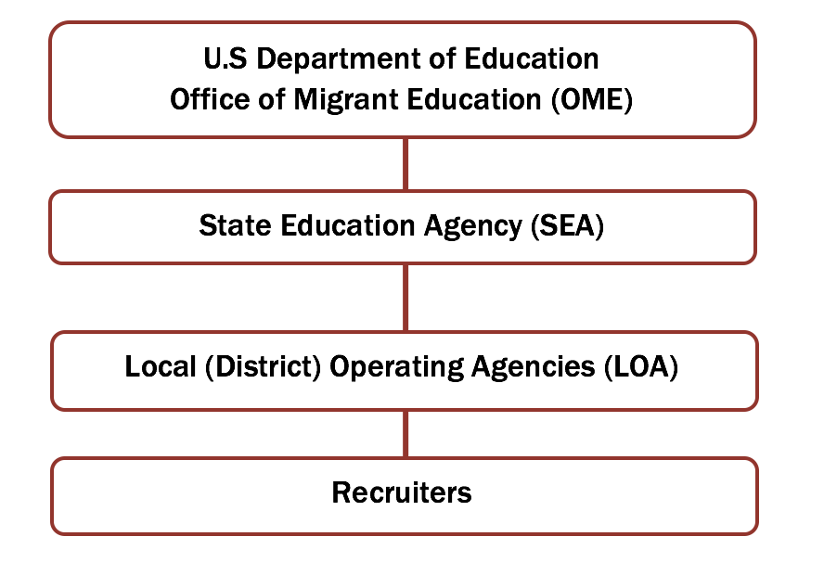
Role of Federal MEP Staff. OME administers the MEP nationally and provides guidance and support to SEAs that receive grants. The OME has several responsibilities, including providing national leadership, conducting special initiatives, helping ED to calculate state MEP allocations, monitoring state programs for compliance with federal requirements, collecting and analyzing student performance data, developing regulations and guidance, and providing technical assistance on how to implement the MEP. A federal program officer (i.e., contact person) is assigned to each state to assist and monitor its implementation of the MEP.
The OME has developed Non-Regulatory Guidance (NRG), a policy document that is written in an easy-to-follow question-and-answer format to help SEAs and LOAs understand the requirements that apply to the MEP and to suggest ways to implement them. As statutory or regulatory requirements change, OME updates the NRG to help clarify the policies as they relate to the MEP. Recruiters are strongly encouraged to study the Chapters II and III of the NRG on “Child Eligibility” and “Identification and Recruitment.”
Role of State MEP Staff. ED awards MEP formula grants to SEAs, which are solely responsible for the operation and administration of the program; most SEAs subgrant a portion of their MEP grant to LOAs, which help SEAs administer and operate the program. At the state level, most states have a MEP Director who is responsible for overseeing all aspects of the administration of the program, including the state’s ID&R system. The MEP Director may also have program responsibilities for other federal programs. The focus of the state MEP Director is to provide overall leadership and direction for the state as a whole, and to ensure that local programs comply with all applicable laws and other requirements. The state is responsible for finding and enrolling migratory children from across the state, for determining their unique needs, and for developing a service delivery plan that uses resources in an equitable and effective manner. Most states also have ID&R Coordinators who provide statewide leadership and guidance to recruiters. When a recruiter asks a question that cannot be answered at the local level, the recruiter should raise the question at the state level for a response. It is important to recognize that each state has its own policies and procedures regarding chain-of-command and how to address questions and concerns. The recruiter should check with an immediate supervisor to learn the protocols in his or her state.
Role of Local MEP Staff. At the LOA level, the emphasis is on finding and serving individual migratory children. The recruiter, perhaps with assistance from other local staff, finds migratory children, determines whether they are eligible for the MEP, and helps connect them with appropriate services. Once the child is identified and the child’s needs are assessed, educators and others at the district level who serve migratory children may provide extra services that are beyond those offered by the local school. For example, MEP teachers and tutors may provide in-home tutoring, after school coursework, or summer programs. Migratory children may also be eligible to receive services through other programs serving migratory students, such as
- The High School Equivalency Program (HEP), under which ED provides competitive grants to colleges, universities and non-profit organizations to help migratory and seasonal farmworkers and their immediate family members who are 16 years of age or older to obtain a HSED certificate or equivalent to gain employment, enter postsecondary education, or the military.
- The College Assistance Migrant Program (CAMP), under which ED provides competitive grants to grants to colleges, universities and non-profit organization to help migratory and seasonal farmworkers and their immediate family members complete their first undergraduate year of study in a college or university.
Local school districts that receive a subgrant from the SEA to serve migratory children are responsible to the state MEP. When a recruiter or anyone else at the local level has a question or needs support, the recruiter should turn to an immediate supervisor for assistance. The supervisor may be an ID&R staff member or a local program coordinator who has broader duties. Local projects are often asked to gather local data for the state for evaluation purposes and also to inform state decision makers.

Conclusion
The MEP helps meet the academic needs of an important and often overlooked sector of our society: migratory children. If it were not for the efforts of the MEP at the local, state, and federal levels, migratory children might remain invisible. In many cases, migratory children would not be identified or served if MEPs did not employ a network of recruiters to find and enroll them into the program. Without a record of eligibility, these children would not be able to receive the additional services they need to be successful. There are many layers of support at the local, state and federal levels of the MEP, so the recruiter should never feel that he or she is alone.

Many migratory families have a home base or hometown where they live for much of the year. They travel or migrate from this home base to other places to work.

